**Design and Fabrication of Microfluidics Devices**

**using Soft Lithography**

**By**

**Muhammad Abdullah**

**Muhammad Manan Nasir**

**Thesis submitted to the Faculty of Engineering at PIEAS in partial fulfillment**

**of requirements for the Degree of B.S. Mechanical Engineering**

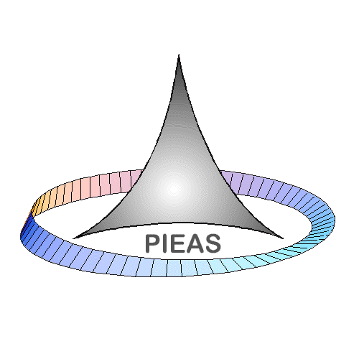

**Department of Mechanical Engineering**

**Pakistan Institute of Engineering & Applied Sciences**

**Nilore, Islamabad, Pakistan**

**August, 2024**

Allah is the guardian of those who believe. He brings them out of the darkness into the light; and (as to) those who disbelieve, their guardians are Shaitans who take them out of the light into the darkness; they are the inmates of the fire, in it they shall abide.

THE COW [Verse 2.257]

**Department of Mechanical Engineering,**

**Pakistan Institute of Engineering and Applied Sciences (PIEAS)**

**Nilore. Islamabad 45650, Pakistan**

**Declaration of Originality**

We hereby declare that the work contained in this thesis and the intellectual content of this thesis are the product of our own work. This thesis has not been previously published in any form nor does it contain any verbatim of the published resources which could be treated as an infringement of the international copyright law.

We also declare that we do understand the terms ‘copyright’ and ‘plagiarism’, and that in case of any copyright violation or plagiarism found in this work, we will be held fully responsible for the consequences of any such violation.

Signature: ___________________________

Name: ______________________________

Signature: ___________________________

Name: ______________________________

Date: ____________________

Place: ____________________

**Certificate of Approval**

***This is to certify that the work contained in this thesis entitled***

**“Design and Fabrication of Microfluidic Devices**

**using Soft Lithography”**

***was carried out by***

**Muhammad Abdullah And Muhammad Manan Nasir**

***Under our supervision and that in our opinion, it is fully adequate, in scope and quality, for the degree of B.S. Mechanical Engineering from Pakistan Institute of Engineering and Applied Sciences (PIEAS).***

***Approved By:***

**Signature:** ________________________

**Supervisor:** ***Dr. Shazia Bahir***

**Signature:** ________________________

**Co-Supervisor: *Dr. Waseem Siddique***

***Verified By:***

**Signature:** ________________________

**Head, Department of Mechanical Engineering**

**Stamp:**

**Dedication**

***Dedicated to***

***My mother***

**To my mother, a beacon of strength and grace, who has nurtured me with unwavering love, guided me with wisdom, and instilled in me the values of faith and perseverance.**

***Dedicated to***

***My father***

**To my father, the cornerstone of my achievements, whose unwavering support and belief in me have shaped who I am today. His exemplary guidance and dedication have inspired me to work tirelessly toward my aspirations.**

**Acknowledgement**

First and foremost, all praise and gratitude belong to Allah, the Almighty, on whom we rely for sustenance and guidance. May the peace and blessings of Allah be upon Prophet Muhammad (Peace Be Upon Him), the eternal beacon of knowledge and guidance for humanity.

We would like to express our deepest gratitude to our advisor, **Dr. Shazia Bashir**, for her invaluable time, insightful suggestions, motivation, enthusiasm, and profound knowledge. Her guidance has been instrumental in shaping our thesis research, and we are immensely grateful for her mentorship.

We also extend our sincere thanks to **Mr. Muhammad Fahad**, Professor at COMSATS University Islamabad, for his support, ideas, and for illuminating our initial steps into the realm of research. His contributions have been vital to our progress.

Finally, we are deeply thankful to our parents, siblings, dear friends, and teachers for their unwavering support, thoughtful comments, and encouragement throughout this journey. Their belief in us has been a source of strength and inspiration.

**Muhammad Abdullah**

**Muhammad Manan Nasir**

**Table of Contents**

1 Introduction 1

1.1 Microfluidics 1

1.1.1 Microfluidics Applications 1

1.2 Droplet Generation 2

1.2.1 Device Geometries 2

1.2.2 Active methods of Droplet Generation 3

1.2.3 Mechanism of Droplet Generation 5

1.2.4 Available Methods of Droplet Generation 9

1.3 Droplet Breakup and Sorting 12

1.4 PDMS Microfluidics 13

1.5 Problem Statement 16

2 Literature Review 17

3 Design Methodology 21

3.1 Problem Statement 21

3.2 CAD MODEL 22

3.3 Microfabrication Technique 24

4 Fabrication Methodology 26

4.1 Preparation of Mold 26

4.1.1 Argon Plasma Treatment 27

4.1.2 Spin Coating with Photoresist 29

4.1.3 Soft Baking 30

4.1.4 UV Exposure 31

4.1.5 Post-Exposure Baking 33

4.1.6 Pattern Visibility Check 34

4.1.7 Developing the Channel 35

4.2 PDMS Casting 37

4.2.1 Mixing PDMS Elastomer and Curing Agent 37

4.2.2 Degassing the Mixture 38

4.2.3 PDMS Casting and Curing 39

4.2.4 Punching Holes 40

4.2.5 Plasma Bonding 40

4.3 Validation and Testing 41

4.4 Conclusion 41

5 Results and Discussion 43

5.1 Droplet Breakup at Entrance of Channel i n a Microfluidic System 43

5.2 Introduction 43

5.3 T-junction & Droplet Generation 45

5.3.1 Influence of Capillary Number 48

5.3.2 Influence of flow rate ratio Q 49

5.3.3 The Scaling Law 51

5.4 Conclusions 52

References 54

**List of Figures**

Figure 1‑1: Schematic showing geometries for droplet generation (a) T-junction, (b) flow-focusing geometry, and (c) co-flow geometry. Here Qc represents the flow rate of the continuous fluid, and Qd represents the flow rate of the discontinuous fluid. 3

Figure 1‑2: Active methods of droplet generation (a-h) Single-layer microvalves for control of droplet size and frequency in a flow-focusing device [16]. (i) Application of SAW near the flow-focusing junction for controlling droplet size [17]. Reproduced from [16] and [17] with permission 5

Figure 1‑3: A schematic representation of the shape of the discontinuous phase entering the main channel, which is carrying a continuous phase just before the droplet generation. Pc and Pd represent hydrodynamic pressure in the continuous and discontinuous phase, respectively. 7

Figure 1‑4: Variation of Pc, Pd and ∆P during droplet generation at T-junction [21]. (a-b) Pressure acting on a droplet along with radius of curvature. (c-e) Variation of pressure acting on a droplet during different stages of droplet generation. Reproduced from ref. [21] with permission. 11

Figure 1‑5:Scheme describing rapid prototyping of microfluidic systems 15

Figure 3‑1: Engineering Drawing of Previous Model 23

Figure 3‑2: CAD Model 23

Figure 3‑3: PDMS Casting Process 25

Figure 4‑1: Plasma Treatment 27

Figure 4‑2: Water droplet on a plasma treated surface 28

Figure 4‑3: Water droplet on an untreated surface 29

Figure 4‑4: Extracting value of speed against desired thickness 29

Figure 4‑5 : Coating substrate with SU-8 photoresist 30

Figure 4‑6 : Soft Baking 31

Figure 4‑7 : UV Exposure 32

Figure 4‑8 : Photomask 32

Figure 4‑9 : Placing substrate in oven for PEB 34

Figure 4‑10: Pattern Visibility Check 35

Figure 4‑11 : Developing the Channel 36

Figure 4‑12 : Weighing PDMS Elastomer 37

Figure 4‑13 : PDMS+Curing Agent weight 37

Figure 4‑14: Mixture Containing Bubbles 38

Figure 4‑15 : Degassing through Vacuum Desiccator 38

Figure 4‑16 : Vacuum Chamber 39

Figure 4‑17 : Pouring PDMS 39

Figure 4‑18 : Curing PDMS 39

Figure 4‑19: Peeling off the PDMS 40

Figure 4‑20: Punching Holes 40

Figure 4‑21 : Plasma Bonding 41

Figure 5‑1: The droplet generation in Chip1 in the squeezing regime with Ca= 0.0036 and Q=1.2. The frame rate is 100fps, and the magnification rate is 10. 46

Figure 5‑2: The droplet generation in Chip 1, the dripping regime with Ca=0.019 and Q=1. The frame rate is 100fps, and the magnification rate is 10. 47

Figure 5‑3: Examples of the jetting regime [77]. 48

Figure 5‑4: The impact of the capillary number on the droplet diameter at flow rate ratios 0.05, 0.1, 0.15, 0.2, 0.25 and 0.3 for Chip. 48

Figure 5‑5: Chip in squeezing, transition and dripping regimes 49

Figure 5‑6 : The Excel sheet of the measured droplet diameters (µm) and standard error results of Chip 1 for Q= 0.05, 0.1, 0.15 50

Figure 5‑7 : The impact of the flow rate ratio on the droplet diameter at the capillary number in a range from 0.0017 to 0.0204 for Chip. 50

**List of Tables**

Table 1‑1: Variation of Laplace pressure, the pressure of the continuous and discontinuous phase during four stages of droplet generation. 12

Table 1‑2: Properties of PDMS [22] 14

Table 3‑1: Table of Diffusion Coefficients in Water [23] 21

Table 4‑1 : Soft Baking Time Duration for Required Thickness 31

Table 4‑2 : UV Exposure Energy against required thickness 33

Table 4‑3: Post Exposure Baking Time 33

Table 4‑4 : Development time against required thickness 36

Nomenclature

|  |  |
| --- | --- |
| Symbols | Definition |
| *Ca* | Capillary Number |
| *Pe* | Peclet Number |
| *Bo* | Bond Number |
| *We* | Weber Number |
| *μ* | Viscosity of the continuous phase (*Pa.s*) |
| *ν* | Velocity of the continuous phase (*µm/s*) |
| *γ* | Interfacial tension (*N/m*) |
| *ΔP* | Laplace Pressure (*Pa*) |
| *r* | Radius of curvature (*µm*) |
| *w* | Width of the microchannel (*µm*) |
| *h* | Height of the microchannel (*µm*) |
| $$Q_{c}$$ | Flow rate of continuous phase (*µL/min*) |
| $$Q_{d}$$ | Flow rate of discontinuous phase (*µL/min*) |
| $$P_{c}$$ | Pressure of continuous phase (*Pa*) |
| $$P_{d}$$ | Pressure of discontinuous phase (*Pa*) |
| *Δt* | Time step in simulations (*s*) |
| $$F_{R}$$ | Resistance to the flow of continuous phase (*µN*) |
| $$P_{h}$$ | Pressure in head of the droplet (*Pa*) |
| $$P_{t}$$ | Pressure in tail of the droplet (*Pa*) |
| *d* | Separation distance (*µm*) |

# Introduction

There has been a significant increase in the attention of microfluidic devices since their introduction in 1990s. Miniaturization, highly throughout precise and control, reduced reagent consumption and improved sensitivity have made these devices very appealing for numerous biological and chemical applications. Microfluidic devices exhibit significant potential for decreasing manufacturing costs, reagent consumption, and analysis time, while concurrently enhancing device efficiency and portability. [1]  
The development of soft lithography techniques for microfabrication has increased interest in fluid flow at the microscopic level [2,3]. Over the past two decades, microfluidics has attracted broad interest in multiple research areas from engineering to life science and physical chemistry, as an emerging interdisciplinary field. This multifunctional technology comes with several benefits, e.g. lower fluid consumption of micro- to nanoliter scale decreasing the sample and reagent costs minimizes overall set-up volume creates a high surface-to-volume ratio In addition, it allows for fast cycling and high-throughput analyses. By utilizing economical microchips or lab-on-chip (LOC) devices, microfluidics has the power to replace traditional laboratory equipment in processes such as mixing, pipetting centrifugation and incubation.

## Microfluidics

Microfluidic systems typically come with channels that are usually tens to hundreds of microns in size. These systems manage small amounts of fluids, ranging from 1 atto-liter to 1 nano-liter [4,5]. In the beginning, silicon, quartz or glass materials were used for fabrication of microfluidic devices. Most research in microfluidic system is now carried out in polymers. Fabrication in polymers is easier, more flexible, and much less expensive than in silicon or glass.

### Microfluidics Applications

The micro-nanometer sized droplets have enormous applications in cosmetics, food, printing, nutrition and pharmaceutical industry, as a micro-reactors for chemical reactions, as drug carriers, in bio-analyses and material synthesis, catalysis, suspensions and for manipulation of samples of a single cell or a single molecule. [6]

## Droplet Generation

The first step in creating any droplet-based microfluidic device is to generate droplets that are uniform in size and shape. Typically, this droplet generation happens passively, meaning it doesn't require any external energy or control. However, for more selective purposes, some researchers have used active methods to produce droplets. There are three main designs for generating droplets passively: T-junctions, flow-focusing, and co-flow devices. Additionally, some researchers have explored active methods like pneumatic microvalves, surface acoustic waves, and electric fields to create droplets on demand. Droplet generation can also be classified into three types—squeezing, dripping, and jetting—depending on the forces involved. In this overview, we’ll first look at the different designs and techniques used for droplet generation.

### Device Geometries

#### T-junction

T-junctions are among the most widely used geometries for generating droplets. In this setup, two immiscible fluids—one acting as the continuous/carrier fluid and the other as the discontinuous/dispersed fluid—meet at a right angle to produce uniform droplets, as illustrated in Figure 1-1 (a). This method was first employed by Thorsen et al. [7] to create stable droplets. The size of the droplets, the frequency at which they are generated, and the distance between them in a T-junction depend on several factors, including the flow rates of the two fluids, interfacial tension, Capillary Number, and the dimensions of the geometry. The continuous and discontinuous fluids are fed into the junction through two separate channels. As they meet, an interface forms at the junction, and over time, a small portion of the discontinuous phase enters the main channel. The head of the discontinuous phase continues to elongate until the neck narrows, eventually leading to the formation of a droplet from the discontinuous fluid.

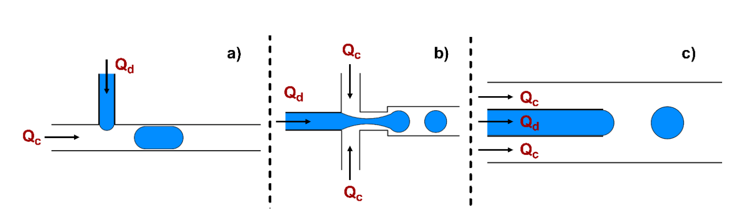

Figure ‑: Schematic showing geometries for droplet generation (a) T-junction, (b) flow-focusing geometry, and (c) co-flow geometry. Here Qc represents the flow rate of the continuous fluid, and Qd represents the flow rate of the discontinuous fluid.

#### Flow Focusing

In flow-focusing devices, the discontinuous fluid is broken into droplets by two streams of continuous fluid, as illustrated in Figure 1-1 (b). These two streams of continuous fluid apply shear forces to the dispersed phase, leading to controlled and stable droplet formation. Anna et al. [8] were the first to introduce flow-focusing geometries. While these geometries are more complex to operate compared to T-junctions—due to the involvement of three fluid streams—they offer improved monodispersity and greater control over droplet size. This makes them particularly suitable for handling biological samples and for producing smaller droplets with precise control. The key factors influencing droplet production in flow-focusing devices include the viscosity and flow rates of the two phases. Various adaptations of flow-focusing geometries have been developed to suit specific applications.

#### Co-flowing

In co-flow geometries, continuous and discontinuous fluid streams flow parallel to each other, with two streams of the continuous phase bordering the discontinuous phase on both sides. This results in a thinning of the discontinuous phase thread, and ultimately the formation of droplets, as shown in Figure 1-1 (c). Umbanhowar et al. [9] demonstrated the use of co-flow devices for the first time. The physics of flow-focusing devices and co-flow devices are similar.

### Active methods of Droplet Generation

Passive droplet generation methods can continuously produce droplets of similar size, but they lack the ability to selectively or on-demand control droplet production. In situations where adjusting the volume of samples or reagents is important, active droplet generation methods become more attractive due to their enhanced control over the process. Active methods use external actuation or energy sources for droplet formation, rather than relying solely on the geometric design of the channels. While incorporating active droplet generation techniques into a microfluidic chip increases the device's complexity and cost, it also provides additional control over various parameters and enables on-demand droplet production, which is particularly useful in chemical and biological screening processes.

Several researchers have successfully demonstrated the use of active methods, such as single- or multi-layer pneumatic microvalves [10], surface acoustic waves (SAW) [11], dielectrophoresis [12], electrowetting [13], thermal actuation [14], and magnetic actuation [15], for droplet generation.

For example, Abate et al. [16] used single-layer pneumatic microvalves to precisely control the size and frequency of droplets generated in a flow-focusing device. Two microvalves were positioned near the flow-focusing junction. The researchers showed that without activating the valves, droplets of a specific size and frequency were produced based on the flow rates of the continuous and discontinuous phases, as depicted in Figure 1-2 (a-h). When the valves were systematically pressurized, a wide range of droplet sizes and frequencies could be achieved without altering the flow rates.

Similarly, Schmid et al. [17] utilized surface acoustic waves (SAW) near the flow-focusing junction for droplet generation. They demonstrated that by adjusting the power of SAW, the size of the droplets could be controlled. The droplet size was found to be inversely proportional to the SAW power, while the frequency of droplet generation was directly proportional, as shown in Figure 1-2 (i). In later work, the authors [18] expanded their study to include T-junctions operating in a squeezing regime.

Additionally, Collins et al. [11] used SAW to produce on-demand picoliter-sized droplets. The volume of these droplets could be adjusted by varying factors such as the applied power, the duration of SAW actuation, and the geometric configuration of the device.

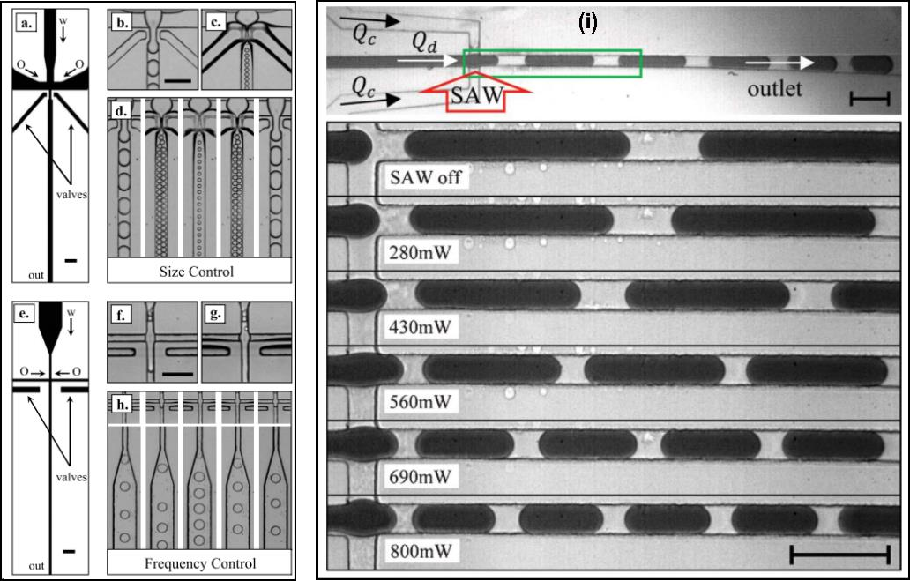

Figure ‑: Active methods of droplet generation (a-h) Single-layer microvalves for control of droplet size and frequency in a flow-focusing device [16]. (i) Application of SAW near the flow-focusing junction for controlling droplet size [17]. Reproduced from [16] and [17] with permission

### Mechanism of Droplet Generation

Two theories have been proposed to explain the mechanism of droplet generation in microfluidic systems: the 'shear-driven droplet generation' theory by Thorsen et al. [7] and the 'rate-of-flow controlled generation' theory by Garstecki et al. [19]. Before delving into the specifics of these theories, it's important to first understand the dimensionless numbers and forces that influence the droplet during its formation.

#### Important Dimensionless Numbers in Droplet Microfluidics

Various dimensionless numbers play an important role in droplet formation; these dimensionless parameters are explained below.

##### Capillary Number

The Capillary Number represents the relative effect of viscous forces against the interfacial tension between the two immiscible fluids. Mathematically, the Capillary Number is given as:-

$$Ca= \frac{μV}{γ}$$

Where μ, V, and γ represents dynamic viscosity, the velocity of the continuous fluid and interfacial tension between two immiscible phases (continuous and discontinuous phase), respectively[20]. Generally, for applications involving microchannels and microfluidic droplet generation, the Capillary Number is small (less than 0.1), hence it indicates that capillary forces are more dominant than viscous forces.

##### Peclet Number

The Peclet number is the ratio of advection transport rate to diffusion transport rate of a particular physical quantity (for example heat, mass). Mathematically, the Peclet Number is given by,

$$Pe=\frac{Advection Transport Rate}{Diffusion Transport Rate}=\frac{L u}{D}$$

Where *L* represents the characteristics length, *u* represents the velocity of the continuous phase, and D represents the diffusion coefficient.

##### Bond Number

The bond number is the ratio of body forces versus surface tension forces.

$$Bo= \frac{Δρ L^{2}}{σ}$$

Where Δρ, g, and σ represents the density difference between the two phases (continuous and discontinuous phase), gravity, and interfacial tension between two phases, respectively. Bond Number plays a crucial role in determining the shape of a droplet moving in the microfluidic system. For a Bond Number less than 1, the shape of the droplet in the microfluidic system is approximately spherical.

##### Weber Number

The Weber number shows the relative strength of inertia forces and the surface tension forces.

$$We= \frac{ρv^{2}l}{σ}$$

If the Weber number is greater than one, it indicates that inertia forces dominate over surface tension forces. For droplet generation in microfluidic systems, capillary forces typically dominate inertia forces; hence the value of Weber Number is less than 1.

#### Forces Acting During Droplet Generation

##### Interfacial Force

Interfacial tension depends on the Laplace pressure jump (ΔP) across the droplet interface, which is mathematically given by,

$$ΔP= γ\left[\frac{1}{r_{a}}+\frac{1}{r_{r}}\right]$$

Where ra is the radius of axial curvature and rr is the radius of radial curvature, γ is interfacial tension between two immiscible phases. The radial curvature bound by the height of microfluidic system while the radius of axial curvature is equal to the width (w) of the microfluidic channel upstream and half of the width downstream (w/2), as shown in Figure 1-3.

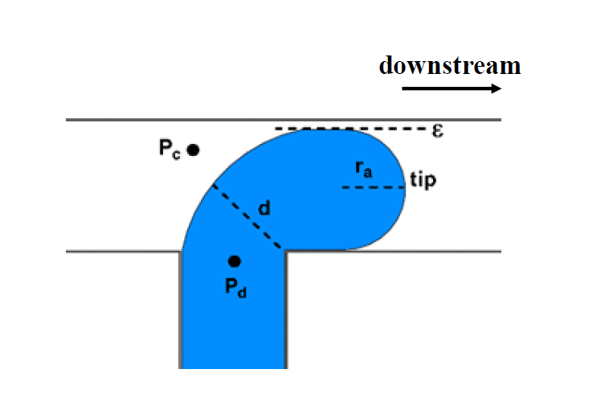

Figure ‑: A schematic representation of the shape of the discontinuous phase entering the main channel, which is carrying a continuous phase just before the droplet generation. Pc and Pd represent hydrodynamic pressure in the continuous and discontinuous phase, respectively.

The Laplace pressure jump upstream and downstream is calculated as follows[O]

$${ΔP}_{upstream}= = γ\left[\frac{1}{w}+\frac{2}{h}\right]$$

$${ΔP}_{downstream}= = -γ\left[\frac{1}{w}+\frac{2}{h}\right]$$

The negative sign in equation 1.7 represents that the force is acting in the opposite direction, adding above two equations and multiplying it by the cross-section area gives the interfacial force[21].

$$F_{γ}=-γh$$

In the absence of any other force acting on the discontinuous phase, the interfacial force acts as a stabilizing effect resisting the process of droplet breaking up from the stream of discontinuous fluid.

##### Shear Force

The shear stress acting on the tip of the discontinuous phase is calculated by using the velocity of the continuous fluid (*ugap*) in the gap between the droplet and the channel wall as follows,

$$u_{gap}=\left[\frac{Q_{continuous phase}}{h.ε}\right]$$

Where ε represents the gap between the droplet and the microchannel wall, we can assume with reasonable accuracy that the flow rate of the continuous phase supplied through the inlet of the main channel is equal to that in ε. Shear stress is calculated as [19]

$$τ≈\left[\frac{μu_{gap}}{ε}\right]$$

Putting the value of *ugap* in the above equation, we get

$$τ≈\left[\frac{μQ_{carrier phase}}{h.ε^{2}}\right]$$

The shear force on a droplet tip at a T-junction is given as,

$$F_{τ}≈\left[\frac{μQ_{carrier phase}}{ε^{2}}\right]×w$$

The shear force calculated above is an overestimation since, we assume that the discontinuous phase tip is static in the main channel; whilst the nature of the discontinuous phase tip is dynamic.

##### Resistance to the Flow of Continuous Fluid

The blocking effect due to the presence of the discontinuous phase tip in the main channel gives rise to the resistance to flow. We can use the Hagen-Poiseuille or thin-film equation to calculate the pressure drop caused due to this resistance to the flow using the value of *ε.* When the value of *ε,* is of the order of w, we can use Hagen-Poiseuille equation.

$$Δp≈\frac{μ.Q_{continuous phase}.w}{h^{2}ϵ^{2}}$$

If $ε≪w$, we can use the pressure drop equation for this film,

$$Δp≈\frac{μ.Q_{continuous phase}.w}{h.ϵ^{3}}$$

$$F_{R}= Δp.h.w$$

$$F_{R}=\frac{μ.Q_{continuous phase}.w^{2}}{h.ϵ^{3}}$$

From the above equations, we observe that values of Fτ and FR are inversely proportional to *ε.*

When $ε≪w$, $F_{τ}> F_{R}$. In the process of droplet generation, stabilization is provided by interfacial force while the other two forces are destabilizing (assisting droplet generation) in nature.

### Available Methods of Droplet Generation

There are different models available for explaining the scaling and mechanism of the droplet generation. Out of these models, two are used widely. First one proposed by Thorsen et al. [7], which is commonly known as a ‘shear driven model’ and the second one is proposed by Garstecki et al. [21], which is commonly known as a ‘rate-of-flow-controlled’ droplet generation. In the following subsection, we will discuss these two models.

#### Shear Driven Droplet Generation

Thorsen et al. [7] conducted a series of experiments by varying the pressures of water and oil to study droplet generation in a microfluidic T-junction. They observed that the size of the droplets depends on both the device's geometry and the pressure or flow rate of the two fluids involved. When the pressure of the oil (the continuous phase) is significantly higher than that of the water (the discontinuous phase), no droplets are formed. However, when the water pressure approaches that of the oil, droplet generation begins. Depending on the ratio of oil to water, droplets of varying sizes and separation distances are produced.

According to this theory, droplet generation results from the interplay between capillary forces and shear forces. The volume of the droplet formed in the T-junction is determined by balancing the Laplace pressure with the shear force acting on the tip of the discontinuous phase. A droplet is generated when the shear force surpasses the Laplace pressure.

$$Δp \sim \frac{μu_{gap}}{ε}$$

$$r \sim \frac{γε}{μu_{gap}}$$

$$∴r \sim \frac{γ}{μ \dot{ϵ}}$$

Where r is the radius of droplet and $\dot{ϵ}$ is the share rate.

#### Rate-of-flow Controlled Droplet Generation

This droplet generation mechanism was proposed by Garstecki et al. [21]. According to this mechanism, droplet formation at the T-junction is primarily controlled by the flow rate or pressure of the continuous (Pc) and discontinuous (Pd) fluids, as illustrated in Figure 1-4. The droplet generation process is divided into four stages:

1) A small portion of the discontinuous phase enters the main channel.

2) The discontinuous phase begins to occupy the cross-section of the main channel.

3) The neck of the discontinuous phase gradually thins.

4) The droplet detaches from the discontinuous phase and moves along the main channel.

To fully understand this process, it is essential to examine the behavior of the continuous phase pressure (Pc) and Laplace pressure (ΔP) during these stages, while assuming that the discontinuous phase pressure (Pd) remains constant. Laplace pressure, described by equation 1.5, decreases during the first two stages because the radial curvature is constrained by the system's height, while the axial curvature increases up to the third stage. Consequently, Laplace pressure reaches its peak just before the droplet detaches from the discontinuous phase.

In the first stage, the condition (Pd − ΔP) > Pc drives the discontinuous phase into the main channel. However, during the second, third, and fourth stages, the pressure in the continuous phase (Pc) continues to rise due to the blockage caused by the continuous fluid. As a result, Pc − (Pd − ΔP) becomes maximum in the fourth stage, leading to the droplet's separation from the discontinuous phase. The variation of pressures throughout these four stages is depicted in Figure 4 (a-e) and summarized in Table 1.

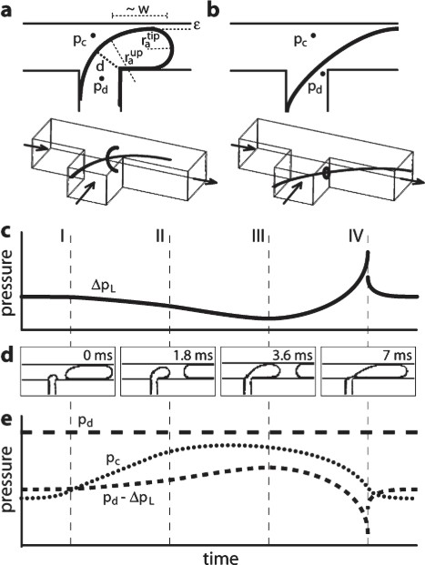

Figure ‑: Variation of Pc, Pd and ∆P during droplet generation at T-junction [21]. (a-b) Pressure acting on a droplet along with radius of curvature. (c-e) Variation of pressure acting on a droplet during different stages of droplet generation. Reproduced from ref. [21] with permission.

Table ‑: Variation of Laplace pressure, the pressure of the continuous and discontinuous phase during four stages of droplet generation.

|  |  |  |  |  |
| --- | --- | --- | --- | --- |
|  | ***Pd*** | ***Pc*** | ∆***P*** | ***Pc – (Pd -*** ∆***P)*** |
| **Stage 1** | Constant | Constant | Decreases | Negative value |
| **Stage 2** | Constant | Increases | Decreases | Positive value |
| **Stage 3** | Constant | Increases | Decreases | Positive value |
| **Stage 4** | Constant | Increases | Increases | Maximum value |

With the help of above analysis, Garstecki *et al*. [19] came up with the scaling relation for determining the size of the droplet formed in T-junction of a microfluidic system. The velocity of the continuous phase is given by:- $$u_{c}≈\frac{Q_{continuous phase}}{h . w}$$

While the velocity of the droplet can be given as,

$$u_{d}≈\frac{Q_{discontinuous phase}}{h . w}$$

The final length of the droplet is equal to

$$L=\left[w+\frac{d.u_{d}}{u_{c}}\right]$$

$$\frac{L}{w}=\left[1+α\left(\frac{Q_{discontinuous phase}}{Q_{continuous phase}}\right)\right]$$

## Droplet Breakup and Sorting

The volume of droplets generated using geometries like T-junctions and co-flow devices tends to be relatively large. These droplets, which carry samples and reagents, are then transported to the desired location on-chip using a technique known as droplet breakup. Depending on the application, the droplets can be divided into symmetric or asymmetric daughter droplets. Droplet breakup techniques are categorized as either active or passive. Active methods rely on an external energy source, such as surface acoustic waves or microvalves, to achieve selective or non-selective droplet breakup. On the other hand, passive droplet breakup methods use changes in the geometry of the system, rather than an external energy source, to accomplish droplet division. In the following section, we will discuss the various methods used to achieve droplet breakup.

## PDMS Microfluidics

A famous name in this context is PDMS polymer. PDMS, or polydimethylsiloxane, has been extensively employed in the research and advancement of microfluidics. PDMS is an elastomer that is optically transparent, and its flexibility can be adjusted, ranging from very soft (easily deformable by finger pressure) to much stiffer. Creating microchannel systems in PDMS is notably uncomplicated. Using PDMS allows for the quick prototyping of devices and simplifies the demonstration and testing of new ideas. The physical and chemical properties of PDMS also enable the construction of devices with a diverse range of functions, extending from molecular analysis to the creation of frequency-tunable lasers.

PDMS, being elastomeric with a tunable Young's modulus of approximately 750 kPa, displays easy deformation, surface conformity, and non-damaging release from molds, even with undercut features. This unique property makes PDMS suitable for high-fidelity replication of microfluidic channels and micron-scale features through replica molding. The use of composite stamps, combining a stiff layer with a flexible PDMS layer, allows replication of features below 1 nm. Additionally, PDMS's elastomeric nature enables the mechanical tuning of optical components. For instance, stretching or compressing PDMS-based surface-relief gratings or Fresnel lenses alters their periodicity, affecting the diffraction pattern or focal properties, showcasing the versatility of PDMS in creating tunable optical devices.

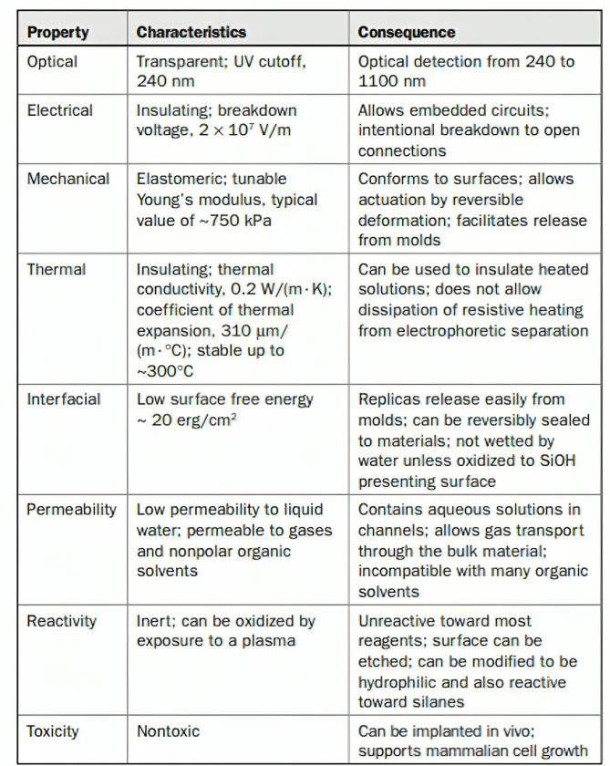

Table ‑: Properties of PDMS [22]

PDMS systems are commonly manufactured using soft lithography techniques. In soft lithography, a topographically defined structure on a master (typically in photoresist) is replicated onto a soft elastomer. This process can be conducted under regular laboratory conditions and allows for multiple replications. Soft lithography offers a quick, uncomplicated and cost-effective fabrication process. The microfluidic channels are initially designed in a CAD program and printed onto a high-resolution transparency or a conventional chrome mask. This transparency serves as a photomask in 1:1 contact photolithography, creating a master with a positive bas-relief of photoresist on a silicon wafer. The master, in turn, acts as a mold for PDMS. Liquid PDMS prepolymer is poured over the master, cured, and then peeled to form a PDMS replica. After plasma oxidation, the replica is sealed to a flat PDMS, glass, or silicon surface to create the microfluidic channels. The entire process typically takes around 24 hours. Refer to Figure for a schematic representation of the involved procedures.

(

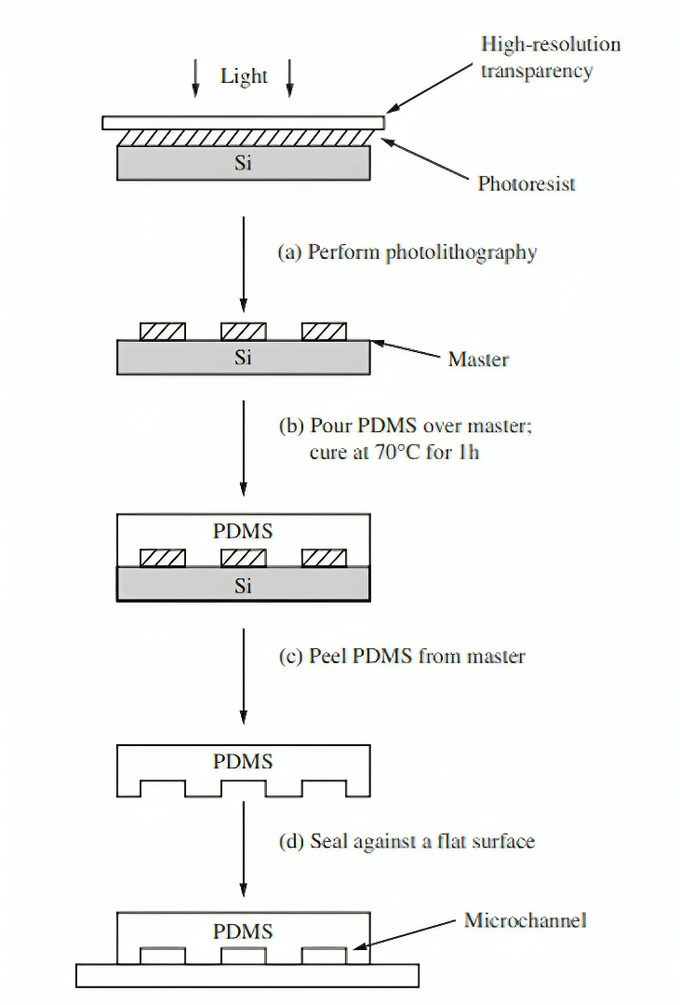

A system of channels is designed in a CAD program. A commercial printer uses the CAD fi le to produce a high-resolution transparency (~5000 dpi). (a) This transparency is used as a photomask in contact photolithography to produce a master. A master consists of a positive relief of photoresist on a silicon wafer and serves as a mold for PDMS. (b) Liquid PDMS prepolymer is poured over the master and cured for 1 h at 70°C. (c) The PDMS replica is peeled from the master. (d) The replica is sealed to a fl at surface to enclose the channels. The overall process takes ~24 h.

Figure ‑:Scheme describing rapid prototyping of microfluidic systems

## Problem Statement

This thesis reports the design and fabrication of microfluidics devices using soft lithography. How can different microfluidics devices should be designed based on required flow rate and diffusion time, making their CAD model in SolidWorks and then shaping that computer model into real one using the process of lithography.

# Literature Review

Microfluidic devices – miniaturized labs on a chip – manipulate fluids with exquisite precision, revolutionizing fields like medicine, drug discovery, and environmental monitoring. These tiny powerhouses offer efficiency, control, and portability, enabling faster analyses, lower costs, and even on-site environmental checks. Soft lithography, a key fabrication technique, makes them accessible and versatile.

While not directly related to microfluidic fabrication, the invention of the transistor in 1947 by **William Shockley, Walter Brattain, and John Bardeen** at Bell Labs laid the foundation for its future development. These three brilliant scientists created the first working transistor, a tiny semiconductor device that could amplify electrical signals. Their invention used germanium and point-contact technology to control current flow with unprecedented precision. The transistor opened the door to miniaturization in electronics, eventually enabling the development of smaller, more powerful chips crucial for microfluidic devices' control systems.

**Jay Andrus** would create the first practical way developing microfluidic channels thanks to his 1955 patent for a photoengraving process. At Eastman Kodak, engineer Andrus came up with a technique that employed photo-sensitive polymers to de-etch material for forming complex micro-channels. The procedure consisted in depositing a light-sensitive polymer on the surface of a substrate, expose it to light through patterned mask and dissolve unexposed regions resulting microchannel patterns. With high-resolution and precision control on fabrication of microfluidic channels, photoengraving-an irreplaceable technique shall play an essential role over the years.

Microfluidic fabrication took a new direction after **Richard Sweet** successfully developed his inkjet printing device in 1965. At IBM, a researcher named Richard Sweet created an apparatus that squirted out tiny ink droplets onto some surface to form simple patterns. The Surface utilized piezoelectric crystals to emit pressure pulses at perfect timestamps and ejected the tiny ink drops through a microdevice, also referred as nozzles onto its platform. Microfluidic channel patterning with inkjet printing allowed rapid, low-cost opportunities. Originally developed for other uses, its potential and versatility pioneered the field of microfluidic printing.

The year 1979 witnessed two crucial breakthroughs that propelled microfluidics into the spotlight: first photolithography and second microscale gas chromatography system. While the photolithography technique itself existed earlier, 1979 marked its first commercial use in magnetic hard disk drive data storage devices. IBM led the charge in this application. Photolithography employs light-sensitive materials like photoresists to precisely pattern microchannels on substrates. Light exposure alters the resist's properties, allowing targeted etching or deposition, creating desired channel geometries. The commercial success of photolithography in data storage demonstrated its scalability, precision, and reliability for microfluidic fabrication. This paved the way for its widespread adoption in diverse fields like microchips, biosensors, and chemical microreactors.

Microscale Gas Chromatography Unit: This concept was first envisioned by, among others Terry S. Buchanan at Stanford University . They downsized gas chromatography analyzers by creating a way to make microchannels on silicon wafers through photolithographic methods. It meant sample volumes were small, analyses quick and the machines moveable. The very nature of the work carried out by the Stanford team served to demonstrate how far microfluidics could be taken in complex analytical applications. Microanalysis it demonstrated improved efficiency, reduced consumption and faster analysis times brought forth by miniaturization, which in turn catalyzed developments of chemical microanalytical systems. These two watershed events in 1979 solidified the foundations of microfludics as a field ripe for developments science and technological. In doing so, they combined the high-precision fabrication offered by photolithography with the analytical power of miniaturized gas chromatography to lay early groundwork for the subsequent expansion and diversification of microfluidics-based applications over decades that followed.

**Charles Hull** introduced stereolithography in 1986 and changed the fabrication game forever. This form of 3D printing led the creation of complex microfluidic channels manufactured in three dimensions, which came when one American engineer named Charles Hull imagined a technique that could create solid objects based on pictures from digital imaging by using polymerization through light. SLA works by using a laser to trace out and harden certain areas of liquid plastic resin, layer by later, in accordance with the requirements of 3D computer model. This capability makes it possible to produce elaborate microfluidic channels with precise configurations and internal characteristics. One of the main benefits for microfluidic fabrication using SLA is that it allows direct 3D fabrication, unmatched design freedom and material versatility. SLA had a huge effect on microfluidics. Suddenly, researchers and engineers could design and manufacture microfluidic devices of an unprecedented level of complexity and functionality (hybrid 3D-printed-microfabricated chips), which allowed for innovative studies in fields ranging from microfluidics-based fabrication techniques like bioprinting or organ-on-a-chip models to the development of new types of functional materials such as highly efficient, miniaturized fluid flow heat exchangers.

While 1997 witnessed several pivotal advancements in microfluidics, the introduction of photoablation by **Stephen P. Roberts** and his team marked a significant milestone. This innovative technique harnessed the power of light to directly carve intricate microfluidic channels within polymer materials, offering a new avenue for microdevice fabrication. Stephen P. Roberts, along with colleagues at Sandia National Laboratories, recognized the potential of laser ablation for microfluidic channel creation. His team pioneered the technique and demonstrated its viability for various polymer materials. Photoablation utilizes focused laser beams to selectively remove material through various mechanisms. For polymers, the laser energy can ablate material through vaporization, decomposition, or photomechanical effects. By precisely controlling the laser parameters and scanning patterns, intricate microfluidic channel geometries can be sculpted directly within the polymer substrate.

While 1997 witnessed several pivotal advancements in microfluidics, the introduction of photoablation by Stephen P. Roberts and his team marked a significant milestone. This innovative technique harnessed the power of light to directly carve intricate microfluidic channels within polymer materials, offering a new avenue for microdevice fabrication. Stephen P. Roberts, along with colleagues at Sandia National Laboratories, recognized the potential of laser ablation for microfluidic channel creation. His team pioneered the technique and demonstrated its viability for various polymer materials. Photoablation utilizes focused laser beams to selectively remove material through various mechanisms. For polymers, the laser energy can ablate material through vaporization, decomposition, or photomechanical effects. By precisely controlling the laser parameters and scanning patterns, intricate microfluidic channel geometries can be sculpted directly within the polymer substrate. Photoablation introduced several advantages for microfluidic fabrication:

* Direct channel creation: Eliminated the need for intermediate masks or molds, simplifying the process and enabling rapid prototyping.
* High resolution and accuracy: Offered exceptional precision in channel dimensions and feature sizes, crucial for complex microfluidic circuits.
* Material versatility: Applicable to various polymers with diverse properties, catering to specific needs like biocompatibility or chemical resistance.

# Design Methodology

## Problem Statement

Let’s we have to mix benzene with water in a micromixer with two inlets at room temperature. The flow rates of both benzene and water are 10 µL/min. Design the length of mixing channel if droplet size requirement is 100 µm.

**Solution:-**

According to Table 10.2 [6], the diffusion coefficient of benzene in water at room temperature (25 °C) is $1.02×{10}^{-5} {cm}^{2}/s$. Channel width will be equal to droplet size, 100 µm.

Table ‑: Table of Diffusion Coefficients in Water [23]

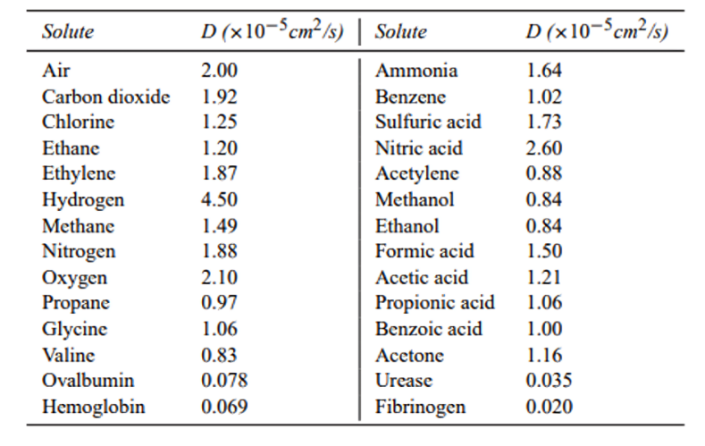

$$Fo=\frac{τD}{w^{2}} τ=Fo\frac{w^{2}}{D}$$

Assuming Fourier Number to be 0.5

Putting values in above equation:-

$$τ=0.5 \frac{{(100×{10}^{-6})}^{2}}{1.02×{10}^{-5}×{10}^{-4}}=4.90 seconds$$

The average velocity of mixed liquid is:-

$$u= \frac{{\dot{Q}}_{water}+{\dot{Q}}_{benzene}}{A}=\frac{2×10×{10}^{-9}/60}{{(100×{10}^{-6})}^{2}}$$

$$u=33.33×{10}^{-3} m/s$$

Thus the requires length of mixing channel is:-

$$L=uτ=33.33×10×4.90=163 mm$$

Total surface area required for the mixing channel is:-

$$A=2wL=2×100×163×1000$$

$$A=3.26×{10}^{7}μm^{2}$$

The dimension of the square area is:-

$$a=\sqrt{A}=\sqrt{3.26×{10}^{7}}≈5709 μm$$

Each turn consumes 2 × 100 µm for walls and 2 × 100 µm for channel width.

The total number of turns is:

$$N=\frac{5709 }{4×100}≈14$$

## CAD MODEL

To solve the problem of effectively mixing benzene and water, I created a CAD model using SolidWorks 2022. The design was carefully based on the calculations made in the previous section, such as the required length and width of the mixing channel to achieve the desired droplet size and ensure proper mixing.

The model features a serpentine channel design, which was chosen because it increases the mixing time by forcing the fluids to travel through several turns. This design helps the fluids mix more thoroughly as they move through the channel. The channel width was set to 100 µm, matching the droplet size requirement, and the overall length of the channel was calculated to make sure the fluids are fully mixed before they exit.

The turns in the channel are designed to enhance the mixing process, ensuring that the fluids interact more as they pass through each turn. The size of the channel and the number of turns were determined by the calculations in the problem statement.

This CAD model not only brings the theoretical calculations to life but also provides a practical design that could be used in real-world applications. The following figure shows the CAD model, highlighting the key features that were included to meet the 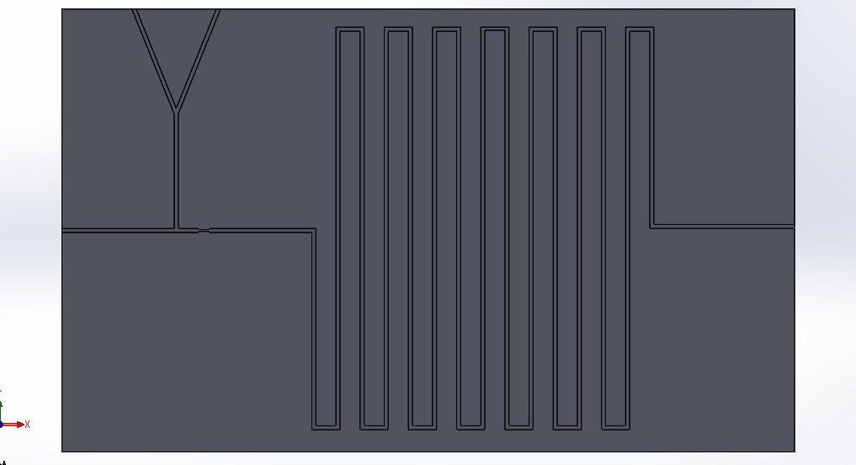specific requirements.

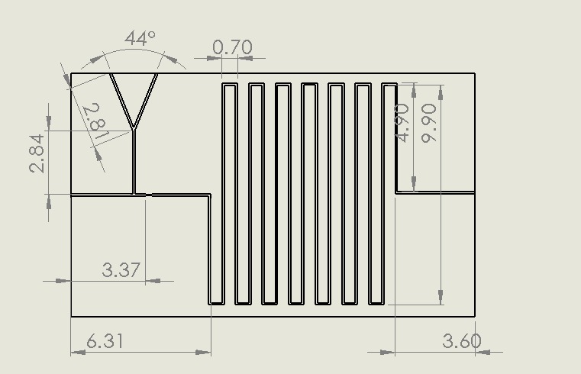

Figure ‑: CAD Model

Figure ‑: Engineering Drawing of CAD Model

## Microfabrication Technique

Soft lithography is a versatile technique used in the fabrication of microfluidic devices. It involves the use of elastomeric materials, typically polydimethylsiloxane (PDMS), to replicate microscale features from a master mold onto the surface of the device. Here's an overview of how soft lithography is done:

Soft lithography is a versatile method widely utilized in the construction of microfluidic devices. It relies on elastomeric materials, such as polydimethylsiloxane (PDMS), to replicate microscale features onto the device surface. The initial phase involves creating a master mold with the desired microscale features, typically done through photolithography. This process includes coating a silicon wafer with a photosensitive material, exposing it to UV light through a photomask, and subsequently developing the exposed photoresist to unveil the microscale pattern on the silicon wafer.

After the fabrication of the master mold, the PDMS prepolymer is meticulously prepared by mixing the base polymer and curing agent in the specified ratio, often at a 10:1 ratio. Subsequently, the PDMS is cast onto the master mold to ensure uniform coverage. To eliminate air bubbles, the PDMS undergoes a degassing process within a vacuum chamber. The next step involves curing the PDMS through a heating process, promoting the crosslinking of polymer chains and solidification.

In the demolding process, the cured PDMS is delicately peeled from the master mold. This negative pattern of the master mold is now successfully replicated onto the PDMS surface. The subsequent steps, including punching holes for inlets and outlets, surface treatment with oxygen plasma, bonding with a substrate (often glass), and the testing and validation of the microfluidic device, ensure a functional and efficient final product. Soft lithography, with its adaptability and cost-effectiveness, has become a prominent method in the creation of intricate microfluidic devices for diverse applications.

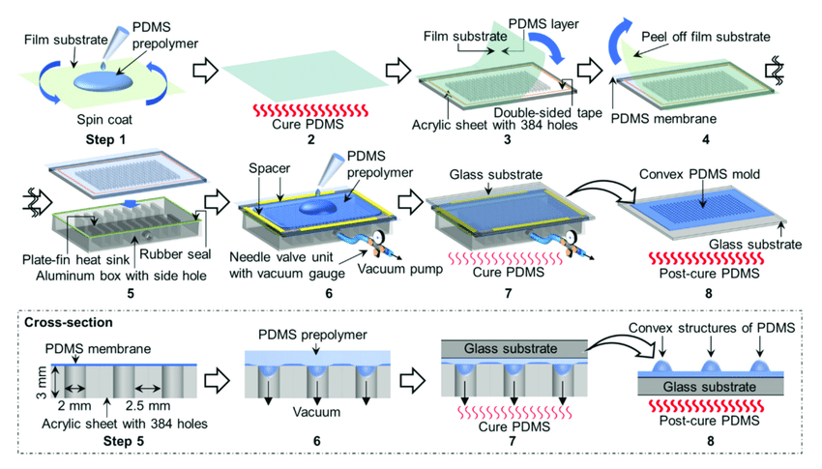

Figure ‑: PDMS Casting Process

# Fabrication Methodology

The fabrication of microfluidic devices involves a series of precise and controlled processes. This chapter details the methodologies we employ in the design and fabrication of microfluidic channels using soft lithography. The specific values provided here are those we use for fabricating a particular device; users should adjust these values based on their own requirements. This process is divided into two main parts:

1. Preparation of the mold via soft photolithography
2. Casting of PDMS channels using the prepared mold.

## Preparation of Mold

Before starting the lithography process, it's crucial to make sure that the surface of the material we're working with is hydrophilic, which means that it can easily interact with water. This is an important step because a hydrophilic surface helps the various chemicals and solutions used in the process to spread evenly, which is necessary for creating accurate and reliable patterns.

Silicon wafers are often the preferred choice for a substrate because they have excellent properties, such as being smooth and highly uniform, which make them ideal for high-precision work. However, the downside of silicon wafers is that they are quite expensive. This high cost can be a significant factor, especially in the early stages of research or when you are just getting started with the lithography process and might make mistakes or need to try different approaches.

To address this, we decided to use glass slides in our initial experiments. Glass slides are much more affordable than silicon wafers, and they still provide a suitable surface for learning the basics of the lithography process. By starting with glass slides, we were able to practice and understand the steps involved in the process without worrying too much about the cost. This approach allowed us to gain valuable experience and confidence. Once we felt comfortable with the techniques and were sure of our process, we then transitioned to using the more expensive silicon wafers. This step-by-step approach ensured that we were well-prepared and that we minimized any potential waste or errors when working with the more costly materials.

### Argon Plasma Treatment

To make the glass slides hydrophilic, a technique known as argon plasma treatment was used. This method is effective because it increases the surface energy of the glass substrate, which is a key factor in making sure that other materials can stick to it properly. By raising the surface energy, the argon plasma treatment helps improve the adhesion between the glass slide and the SU-8 photoresist, which is a material we use to create patterns on the surface. Essentially, this treatment makes the glass slide more receptive to bonding with the photoresist, ensuring that the photoresist adheres well to the slide. The process of using argon plasma treatment is simple yet crucial, as it prepares the glass slides for the next steps by enhancing the surface in a way that promotes better sticking.

1. **Cleaning the Substrate**: Initially, the glass slides are thoroughly cleaned using isopropyl alcohol (IPA) and deionized (DI) water to remove any organic contaminants.
2. **Plasma Treatment**: The cleaned glass slides are placed in a plasma cleaner. Argon gas is introduced, and the slides are exposed to the plasma for 10 minutes. The plasma treatment increases surface energy by adding functional groups, such as hydroxyl groups, making the surface hydrophilic.

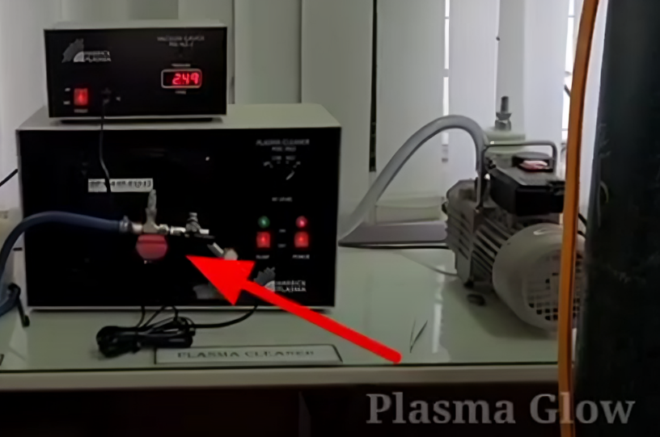

Figure ‑: Plasma Treatment

The effectiveness of the plasma treatment in making the substrate hydrophilic can be assessed by measuring the contact angle of a water droplet placed on the surface. This is a simple yet effective way to determine how well the treatment worked. When a water droplet spreads out flat on the surface, it indicates that the surface is hydrophilic, meaning it has a strong attraction to water. On the other hand, if the droplet remains dome-shaped and doesn't spread out, it suggests that the surface is hydrophobic, meaning it repels water.

To measure the contact angle, we placed a water droplet on both treated and untreated glass slides and observed how the droplet behaved. We used a contact angle goniometer, which is a device specifically designed to measure the angle between the water droplet and the surface. This measurement allowed us to precisely compare the hydrophilicity of the treated slides against the untreated ones.

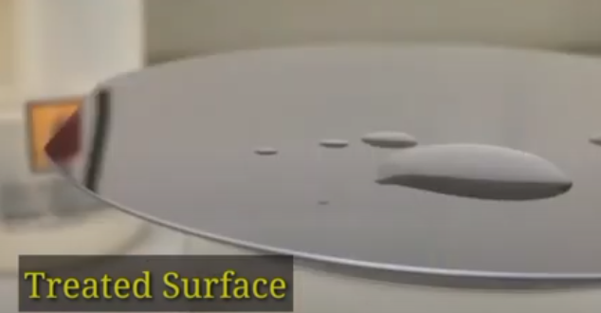The results were clear: the treated glass slides showed a much lower contact angle compared to the untreated slides. This significant decrease in the contact angle confirmed that the plasma treatment was effective in increasing the surface energy of the glass, making it more hydrophilic and better suited for subsequent processes.

Treated Surface

Figure ‑: Water droplet on a plasma treated surface

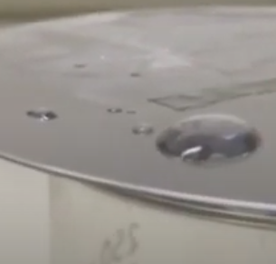

Untreated Surface

Figure ‑: Water droplet on an untreated surface

### Spin Coating with Photoresist

The next step involves spin coating the substrate with SU-8 2075 photoresist to achieve a desired thickness of 200 microns. The spin coating process ensures a uniform layer of photoresist on the substrate. This technique is crucial for achieving the precise thickness and uniformity required for subsequent lithographic processes. Proper control of the spin speed and duration is essential to reach the target thickness, followed by a soft bake to solidify the photoresist layer before further processing.



Figure ‑: Extracting value of speed against desired thickness

The spin coater was set to 1300 RPM based on data provided in the photoresist manufacturer's datasheet. The procedure involves:

1. **Preparation**: The hydrophilic glass slide is placed on the spin coater chuck and secured with a vacuum.
2. **Photoresist Application**: Approximately 5-10 ml of SU-8 2075 photoresist is deposited onto the center of the glass slide.
3. **Spin Coating**: The spin coater is programmed to spin the substrate at 1300 RPM for 30 seconds. This speed and duration are critical to achieving a uniform 200-micron thick layer. The centrifugal force spreads the photoresist evenly across the substrate.
4. 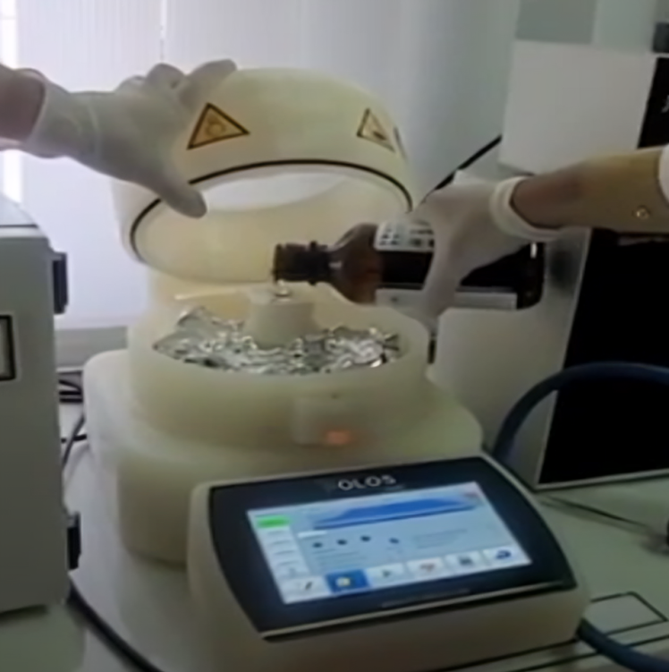**Edge Bead Removal**: Excess photoresist at the edges can be removed using a cleanroom wipe moistened with acetone or IPA.

Figure ‑ : Coating substrate with SU-8 photoresist

### Soft Baking

Soft baking is crucial for evaporating the solvent from the photoresist, thus improving adhesion between the photoresist and the substrate and allowing the UV mask to be applied without sticking. This step typically involves heating the coated substrate on a hotplate or in an oven at a specific temperature and duration, depending on the photoresist formulation. Proper soft baking ensures the photoresist achieves the necessary hardness and reduces the risk of film cracking or delamination during subsequent processing steps. It also helps in achieving a more defined and accurate pattern during the UV exposure step.

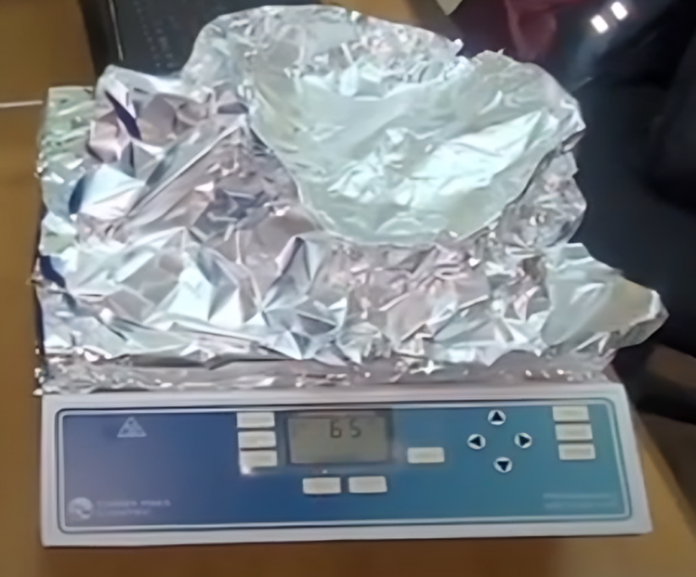

Figure ‑ : Soft Baking

Based on the SU-8 datasheet, the substrate was soft-baked in a convection oven with the following parameters:

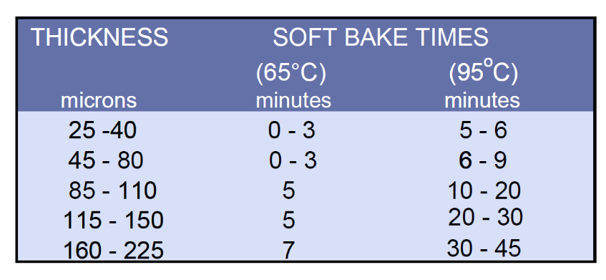

Table ‑ : Soft Baking Time Duration for Required Thickness

1. **Initial Baking**: The coated substrate is placed in an oven at 65°C for 7 minutes. This step initiates solvent evaporation and partially hardens the photoresist.
2. **Secondary Baking**: The temperature is then increased to 95°C and baked for an additional 35 minutes. This step ensures complete solvent evaporation, which is critical for the subsequent UV exposure.
3. **Cooling**: The substrate is allowed to cool gradually to room temperature to avoid thermal shock and potential warping.

### UV Exposure

For UV exposure, a photomask with the desired design was placed onto the photoresist-coated substrate. The UV exposure process transfers the design from the photomask to the photoresist.

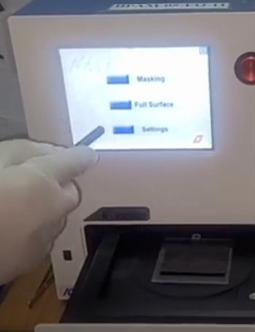

Figure ‑ : UV Exposure

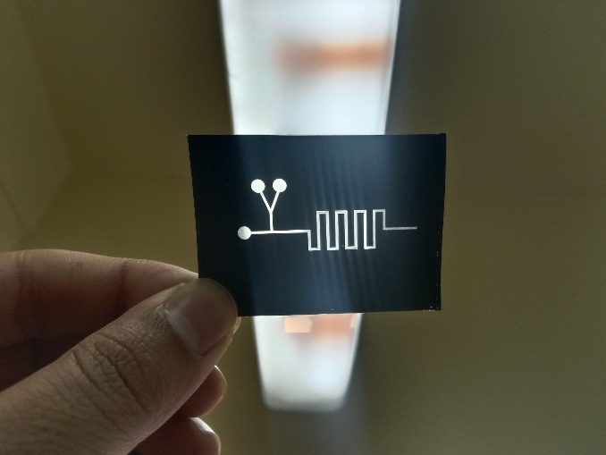The photomask design was created using CAD software such as SolidWorks. The design was printed onto a transparent film suitable for UV exposure. The resolution of the design and the quality of the photomask are critical for the precision of the microfluidic channels.

Figure ‑ : Photomask

The appropriate UV exposure dosage, as recommended in the datasheet, was 45 seconds for a 200-micron thickness. The procedure involves:

1. **Alignment**: The photomask is carefully aligned with the photoresist-coated substrate using an aligner tool to ensure precise pattern transfer.
2. **UV Exposure**: The aligned photomask and substrate are placed in a UV exposure system. UV light is shone through the photomask for 45 seconds, initiating a photochemical reaction in the exposed areas of the photoresist.
3. **Post-Exposure Alignment Check**: After exposure, the photomask is carefully removed, and the substrate is inspected under a microscope to ensure the design has been accurately transferred.

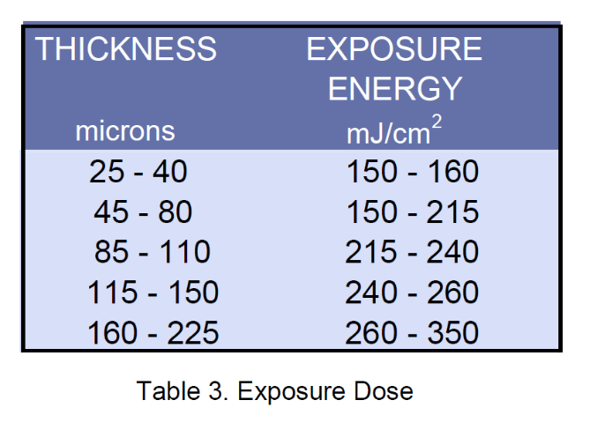

Table ‑ : UV Exposure Energy against required thickness

### Post-Exposure Baking

Post-exposure baking further evaporates solvent, enhances adhesion, and reduces stress by promoting mechanical relaxation. This step is crucial for improving the structural integrity and dimensional stability of the photoresist patterns, ensuring they remain intact during subsequent processing stages.

According to the SU-8 datasheet, the substrate was baked with the following parameters:

Table ‑: Post Exposure Baking Time

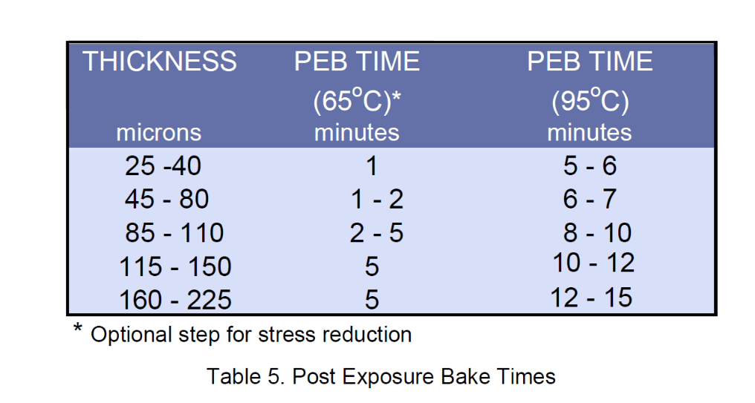

1. **Initial Bake**: The substrate is baked at 65°C for 5 minutes to further solidify the exposed photoresist.
2. **Secondary Bake**: The temperature is then increased to 95°C and baked for an additional 15 minutes. This step strengthens the cross-linked network formed during UV exposure.
3. **Cooling**: The substrate is allowed to cool to room temperature.

### Pattern Visibility Check

Figure ‑ : Placing substrate in oven for PEB

A visible pattern appearing after the post-exposure baking step is a clear sign that the UV exposure was sufficient. This is an important checkpoint in the process, as it confirms that the UV light has effectively transferred the design onto the substrate. To verify this, the substrate should be carefully inspected under a microscope. By doing this, we can ensure that the desired design is not only visible but also sharp and well-defined.

If the pattern appears as expected, it means that the process is on track. However, if there are any issues, such as unclear lines, missing parts of the pattern, or any other defects, these need to be identified and corrected at this stage. Addressing these discrepancies is crucial because any errors left uncorrected can negatively impact the quality and precision of the final microfluidic channels. Ensuring that the pattern is perfect at this point helps guarantee that the final product will meet the required standards and function as intended.

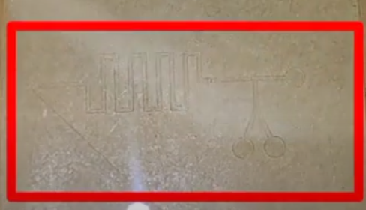

Figure ‑: Pattern Visibility Check

### Developing the Channel

The process of creating the developed channel involves using an SU-8 developer, which plays a crucial role in shaping the final microchannels. The developer works by selectively removing the parts of the photoresist that were not exposed to UV light, effectively leaving behind the desired pattern of microchannels on the substrate. This step is carried out by immersing the substrate into the developer solution and gently agitating it to make sure that all the unexposed photoresist is fully removed.

The time spent in the developer solution, along with the conditions under which the development takes place, must be carefully managed. Precise control is essential to ensure that the channel patterns are clean, accurate, and meet the required specifications. If the development time is too short, some unwanted photoresist might remain; if it's too long, parts of the desired pattern could be dissolved.

Once the development process is complete, the substrate is usually rinsed with isopropyl alcohol (IPA). This rinse serves to stop the development process and helps in removing any traces of the developer that might still be on the substrate. Finally, the substrate undergoes a hard bake. This final baking step is important because it further solidifies and stabilizes the remaining photoresist structures, ensuring that the microchannels are robust and ready for any subsequent processing or use.

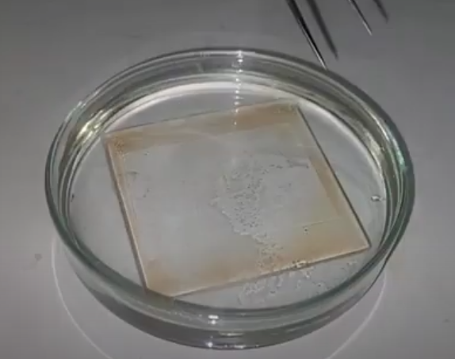

Figure ‑ : Developing the Channel

The development process involves:

1. **Immersion**: The baked substrate is submerged into a beaker containing SU-8 developer.
2. **Agitation**: The beaker is gently agitated or placed on a magnetic stirrer for 15 minutes to ensure uniform development.
3. **Rinsing**: After development, the substrate is rinsed with isopropyl alcohol (IPA) to remove any residual developer. The substrate is then briefly rinsed with DI water.
4. **Drying**: The substrate is dried using an air compressor to achieve a clean and well-defined microchannel pattern. It is critical to avoid drying marks, so a filtered air source is recommended.

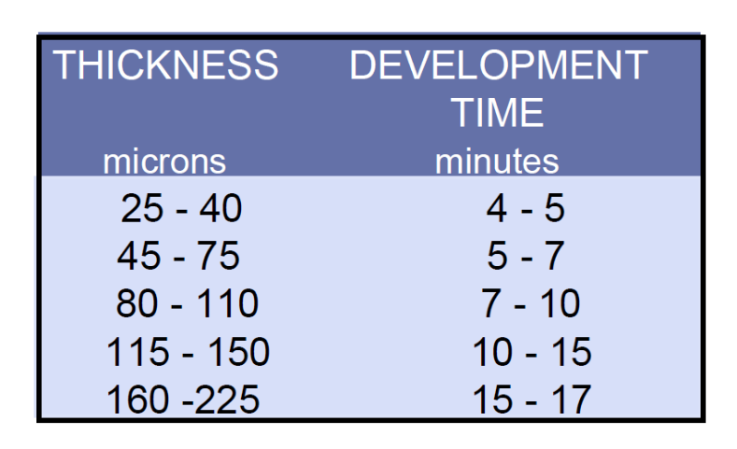

Table ‑ : Development time against required thickness

## PDMS Casting

The second phase involves PDMS casting to create flexible microfluidic channels.

### Mixing PDMS Elastomer and Curing Agent

The PDMS elastomer and curing agent were mixed in a 10:1 ratio. The procedure involves:

1. **Weighing**: A beaker is placed on the weight balance and set to zero. 52 grams of PDMS elastomer are added to the beaker.

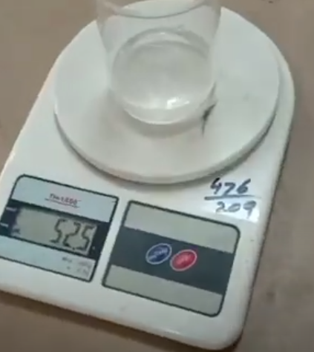

Figure ‑ : Weighing PDMS Elastomer

1. **Adding Curing Agent**: 5 grams of curing agent are then added to the beaker.

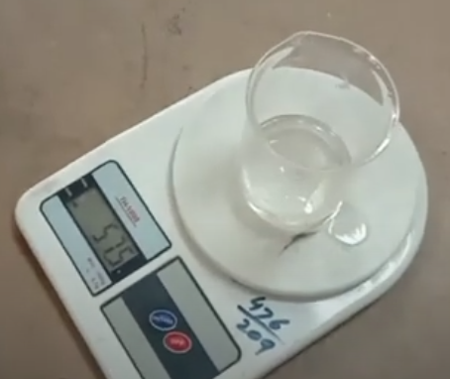

Figure ‑ : PDMS+Curing Agent weight

1. **Mixing**: The elastomer and curing agent are rigorously mixed using a stirring rod or mechanical mixer to form a homogeneous solution. Proper mixing is essential to ensure uniform curing.

### Degassing the Mixture

The mixture contains bubbles that need to be removed to ensure a clear PDMS cast.

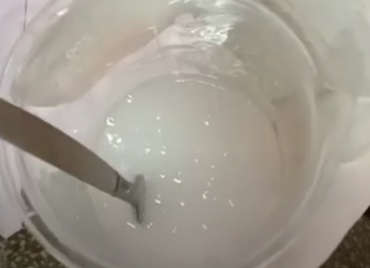

Figure ‑: Mixture Containing Bubbles

The degassing process involves:

1. 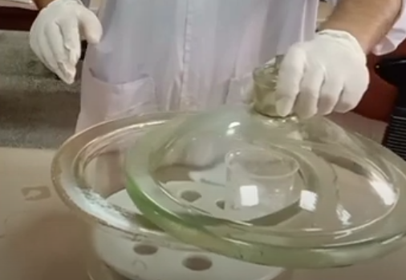**Vacuum Desiccator**: The mixed PDMS solution is placed in a vacuum desiccator to remove air bubbles. This process can take up to 30 minutes, depending on the volume of the mixture and the efficiency of the vacuum pump.

Figure ‑ : Degassing through Vacuum Desiccator

1. **Vacuum Chamber**: To expedite degassing, a chamber with a vacuum pump was used. The low pressure in the chamber allows bubbles to rise and burst more quickly. The degassed PDMS solution becomes clear and bubble-free, ready for casting.

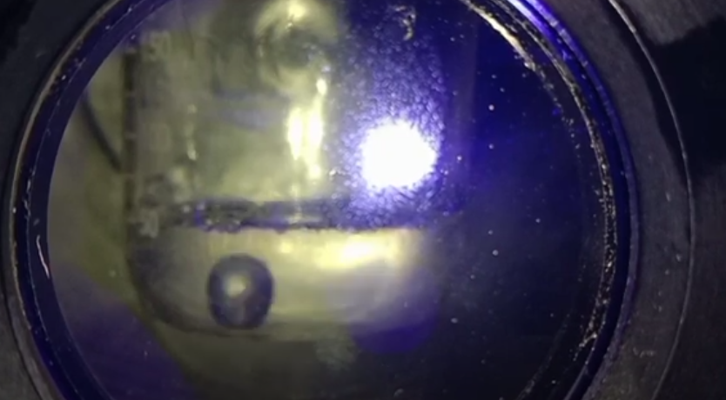

Figure ‑ : Vacuum Chamber

### PDMS Casting and Curing

The PDMS casting process involves:

1. **Pouring**: The degassed PDMS solution is carefully poured over the prepared mold to cover the entire surface evenly.

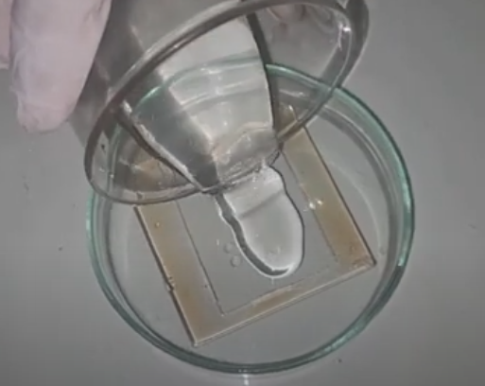

Figure ‑ : Pouring PDMS

1. **Curing**: The mold is placed in an oven at 65°C for 3 to 4 hours. This step ensures that the PDMS cures and solidifies, forming the microfluidic channels.

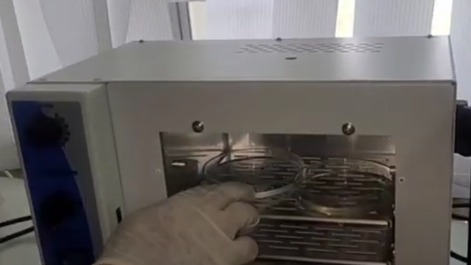

Figure ‑ : Curing PDMS

1. **Cooling and Demolding**: After curing, the mold is allowed to cool to room temperature. The cured PDMS is then carefully peeled off from the mold.

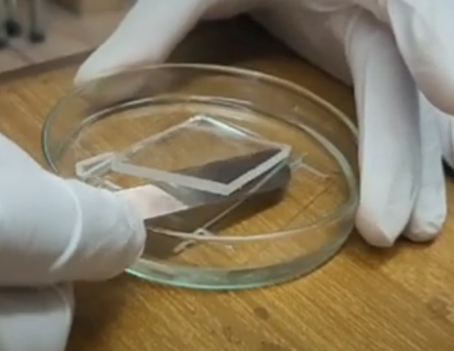

Figure ‑: Peeling off the PDMS

### Punching Holes

Inlet and outlet holes are punched into the PDMS layer using a biopsy punch or similar tool. The placement and size of these holes are critical for fluid flow control in the microfluidic device. Precise alignment ensures efficient fluid entry and exit, minimizing the risk of leaks and ensuring the device functions as intended.

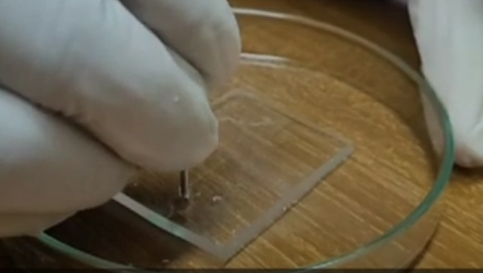

Figure ‑: Punching Holes

### Plasma Bonding

The PDMS layer and another substrate (either another PDMS layer or a glass slide) are plasma treated to enhance bonding. The process involves:

* **Plasma Treatment**: Both surfaces are treated in a plasma cleaner for 1 to 1.5 minutes, depending on the plasma gas used. This treatment activates the surfaces by generating reactive oxygen species, which increases their surface energy.

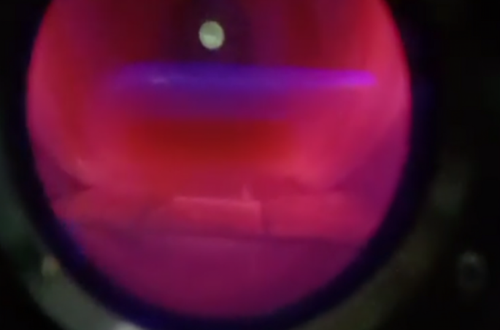

Figure ‑ : Plasma Bonding

* **Bonding**: Immediately after plasma treatment, the treated surfaces are brought into contact and pressed together firmly. Proper alignment is crucial to ensure the channels are sealed correctly.
* **Bond Strengthening**: Although the initial bond is weak, leaving the bonded device at 60°C for 3 days significantly strengthens the bond. This step ensures that the bond between the PDMS layers or between PDMS and the glass slide is robust and durable.

## Validation and Testing

The final fabricated microfluidic device must undergo validation and testing to ensure functionality and reliability.

1. **Visual Inspection**: The bonded device is inspected under a microscope to check for any defects, misalignments, or incomplete bonding.
2. **Leak Test**: The device is subjected to a leak test by introducing a fluid (usually colored dye) through the inlet and monitoring for any leaks or blockages in the channels.
3. **Functional Testing**: The device is tested under operational conditions to verify that it meets the required specifications for fluid flow, mixing, or other intended functionalities.

## Conclusion

The fabrication of microfluidic devices using soft lithography involves multiple precise and controlled steps. Each step, from substrate preparation to PDMS casting and bonding, requires careful attention to detail to ensure the successful creation of functional microfluidic channels. This chapter has detailed the methodologies and procedures followed in the fabrication process, providing a comprehensive guide for future fabrication efforts.

# Results and Discussion

## Droplet Breakup at Entrance of Channel i n a Microfluidic System

*We study how a droplet breaks up at a T-junction in a microfluidic channel through experiments and simulations. The PDMS microchannels are made using photolithography techniques, and we use a high-speed camera to observe the droplets' movements. 3D simulations are performed for situations where droplets either break up or remain intact. The droplets are created at the T-junction, and we focus on how the capillary number (Ca) and the channel geometry affect the breakup. We map out the breakup conditions on a Ca chart, showing the volume of the daughter droplets and the length of the droplet interface. We find that there is a critical value of Ca where breakup occurs. By combining experimental data with simulations, we show that breakup happens if the pressure drop across the droplet and the average shear stress exceed the differential Laplace pressure. We also observe that droplet breakup at the T-junction can exhibit squeezing and dripping behaviors.*

## Introduction

Droplet microfluidics is widely used in various fields like drug discovery, clinical diagnostics, chemical synthesis, single-cell encapsulation, on-chip chemistry, and creating microstructures. Droplets form when two liquids that don’t mix interact in a microfluidic system, with one being the continuous phase and the other the discontinuous phase. By using different designs, droplets can be made in a wide range of volumes from femtoliters (fL) to nanoliters (nL). These droplets are kept separate by the continuous phase, acting like tiny test tubes in a lab-on-a-chip system. The continuous phase also helps move the droplets easily within the microfluidic system.

While droplet production is quick and consistent, it is important to control and manipulate how droplets move and behave in microfluidic systems [24]. Techniques to do this are either passive or active. Passive techniques don't need external energy; they rely on changes in channel design, gravity, and surface properties. Active techniques need external energy and use methods like electric forces, dielectrophoresis, magnetic forces, or surface acoustic waves . Acoustic actuation can create individual droplets on demand and control their volume with the applied power [25], or produce small (fL) droplets. Passive methods produce consistent results for each droplet, while active methods allow customized interactions.

The physics of passive droplet generation at a T-junction shows three distinct behaviors: squeezing, dripping, and jetting [26]. The squeezing regime occurs when the Capillary number (Ca) is less than 0.015, with equal channel widths at the T-junction [53]. Garstecki et al. [27] proposed a model to predict droplet length: $\left(\frac{l}{w}\right)=(1+α\frac{Q_{in}}{Q_{out}})$, where *l* is the droplet length, *w* is the microchannel width, α is a fitting parameter, and *Qin* and *Qout* are the flow rates of the continuous and discontinuous phases. In the dripping regime, droplets form when shear force and pressure at the tip of the discontinuous phase overcome interfacial forces [28]. This happens for Ca > 0.015 [C]. In the jetting regime, the discontinuous phase extends downstream, and both phases flow side-by-side in a laminar flow for a few channel widths.

After droplet generation, research has looked at the conditions needed for droplets to split at T-junctions. Link et al. [29] studied droplet breakup at a symmetric T-junction, showing controlled division of the mother droplet. Their model identified a critical Ca and initial extension of the mother droplet: $ε_{o}=\frac{l_{o}}{πw_{o}}$, where *lo* is the droplet length and *wo* is the channel width. Menetrier-Deremble and Tabeling [30] experimentally studied droplet breakup at junctions meeting at various angles, showing direct breakup, delayed breakup, or no breakup, depending on the critical finger length. Jullien et al. [31] identified two breakup regimes at a symmetric T-junction over a Ca range of $4×{10}^{-4}<Ca<2×{10}^{-1}$, based on the gap between the droplet and the channel wall.

In this chapter, we examine droplet breakup at the entrance to a microfluidic channel. The entrance is configured as a T-junction, where the flow conditions are determined by the internal chip design and the external control at the main channel's outlet. Previous studies have extensively investigated droplet behavior at T-junctions under various conditions. Researchers have demonstrated that different forces and flow rates can influence droplet breakup. Here, we focus on the critical flow conditions and the mechanisms leading to droplet breakup at the T-junction, using experimental and numerical methods to understand the effects of the Capillary number and other influencing factors on the droplet breakup process.

## T-junction & Droplet Generation

The process of droplet generation in a T-junction microfluidic chip can be summarized as follows: First, the continuous flow fluid, typically a non-polar oil, is pumped into the microchannel using a mechanical pump. This pump controls either the pressure or the volumetric flow rate, both of which influence droplet formation. The pressure changes downstream in the channel, impacting how droplets are generated. Therefore, in the design of the T-junction device, the width of the channel remains constant over a specific distance, which is determined by the desired droplet size and the chip’s function.

Similarly, the immiscible aqueous fluid, usually water in medical and biological applications, is also pumped into the system. This channel is positioned perpendicularly to the carrier phase channel, typically forming a right angle. However, this angle can be adjusted depending on the design requirements.

Droplet breakoff occurs either near the intersection area or within the main channel, depending on the flow regime. In the squeezing regime, the droplet fully occupies the main channel. During the breakoff process, the pressure in the continuous flow fluctuates, and after the droplet breaks off, it experiences a higher pressure profile as it moves along the channel.

In 2014, Bashir et al. [32] reported that the position where droplet break up occurs is influenced by the wetting properties of the chip's walls. Specifically, as the hydrophobicity of the walls decreases, the time required to completely block the main channel increases. The effect of larger channels was later explored in 2015 by Korczyk et al. [33], who found that these larger channels produce droplets with greater volume. Such larger droplets are advantageous for certain chemical applications, including the crystallization of proteins.

In this research, our primary focus was on T-junction devices. When two or more immiscible fluids are driven through the inlets towards an intersection, the flow rates determine the variety of flow patterns that are generated. As noted by many researchers, droplets form as the fluid fills the carrier channel, followed by a process of necking and pinching off.

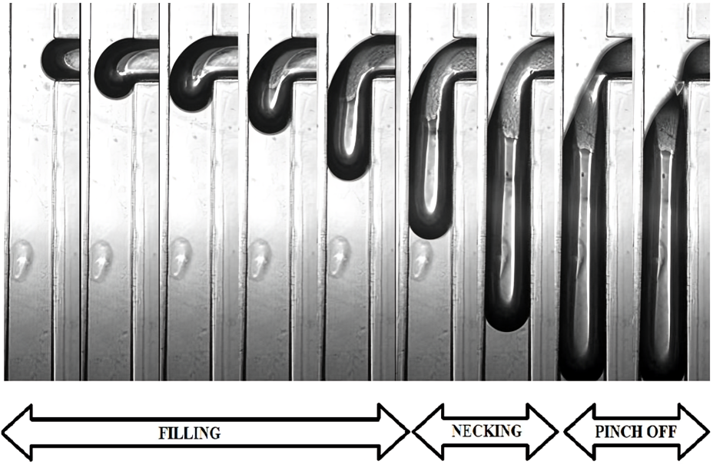

Figure ‑: The droplet generation in Chip1 in the squeezing regime with Ca= 0.0036 and Q=1.2. The frame rate is 100fps, and the magnification rate is 10.

A microfluidic application can be engineered to produce a large number of droplets at rates exceeding 1 kHz. In a system operating at such high speeds, it is crucial to understand the volume of the droplets under varying operational parameters. In the following section, we will first explore the changes in flow patterns and then examine how the droplet size varies across different flow regimes.

A T-junction device is made up of two channels that intersect at a right angle, forming a junction. By adjusting the flow rate of the fluids moving through these channels, the breakup behavior at the intersection can be controlled. Experimentally, four distinct flow regimes have been observed: jetting, dripping, squeezing, and ballooning.

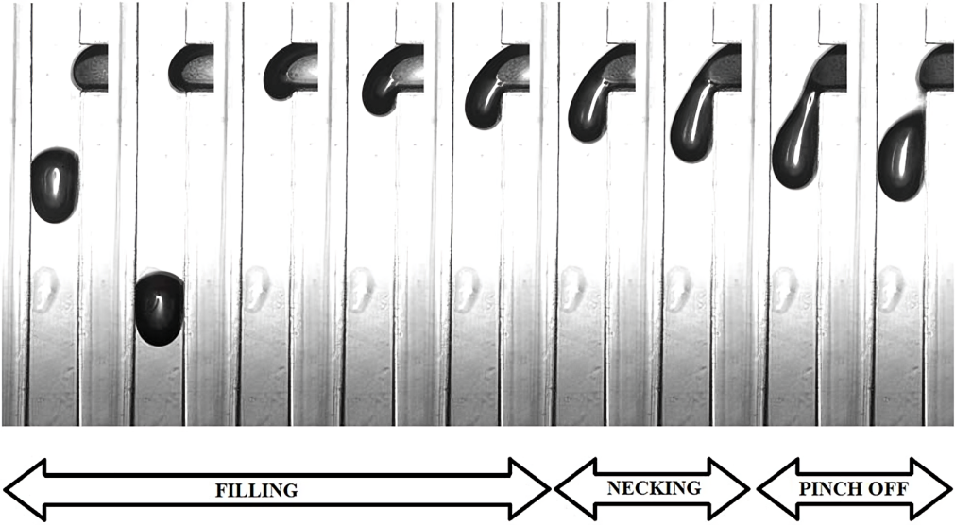

Figure ‑: The droplet generation in Chip 1, the dripping regime with Ca=0.019 and Q=1. The frame rate is 100fps, and the magnification rate is 10.

The precise boundaries between flow regimes, particularly from the dripping to the squeezing regime, are not sharply defined, but their descriptions are well-established. The squeezing regime, as illustrated in Figure 5-2, occurs when the incoming fluid flow fully blocks the junction area of the microfluidic device. In this regime, the interfacial surface tension becomes the dominant force, overpowering the viscous drag and pushing the flow into the main channel. In 2006, Garstecki et al. [34] provided a detailed explanation of droplet generation, focusing on the mechanisms of droplet break-up and the differences between various flow regimes. The squeezing regime is typically observed when the capillary number, Ca, is less than 0.01, specifically around a value of 10-2.

The dripping regime, as shown in Figure 5-3, is more complex and dynamic to describe. In this regime, the interfacial surface tension tries to maintain a stable boundary, but it is counteracted by the advancing interface and the viscous drag at the intersection. As the dispersed phase attempts to completely fill the downstream channel, the shear force from the continuous phase causes the break-up of the droplet. The capillary number in the dripping regime is typically greater than 0.01, indicating that the forces at play differ significantly from those in the squeezing regime.

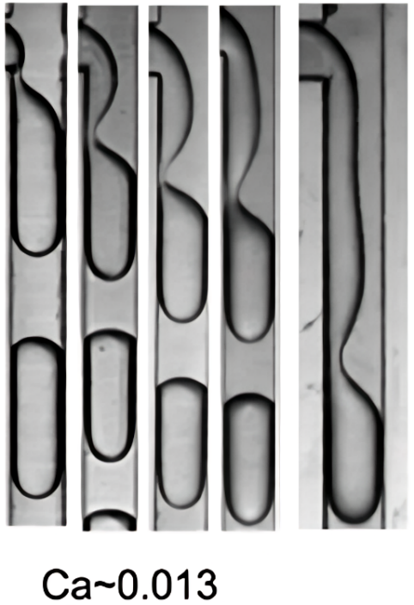

Figure ‑: Examples of the jetting regime [33].

### Influence of Capillary Number

One of the key parameters affecting droplet size is the capillary number. Studies by Garstecki et al. [34] and De Menech et al. [35] have both noted that as the capillary number increases, the size of the droplets decreases. This trend is supported by the experimental data we gathered for the three different chips, as shown in Figures 18, 20, and 21. In these figures, column A represents data recorded in the squeezing regime, columns B and C reflect the transition regime, and column D corresponds to the dripping regime. The droplet generation process is captured in detail, showing the stages step by step: the lag stage, the filling stage, the necking stage, and finally, the detachment of the droplet.

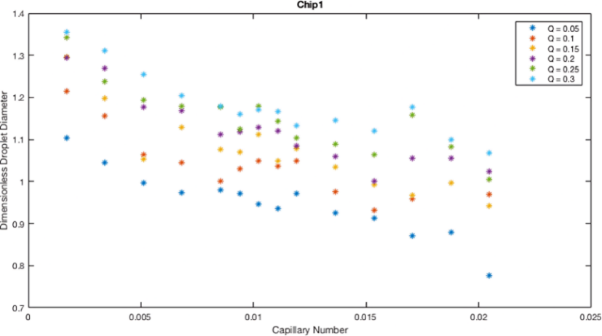

Figure ‑: The impact of the capillary number on the droplet diameter at flow rate ratios 0.05, 0.1, 0.15, 0.2, 0.25 and 0.3 for Chip.

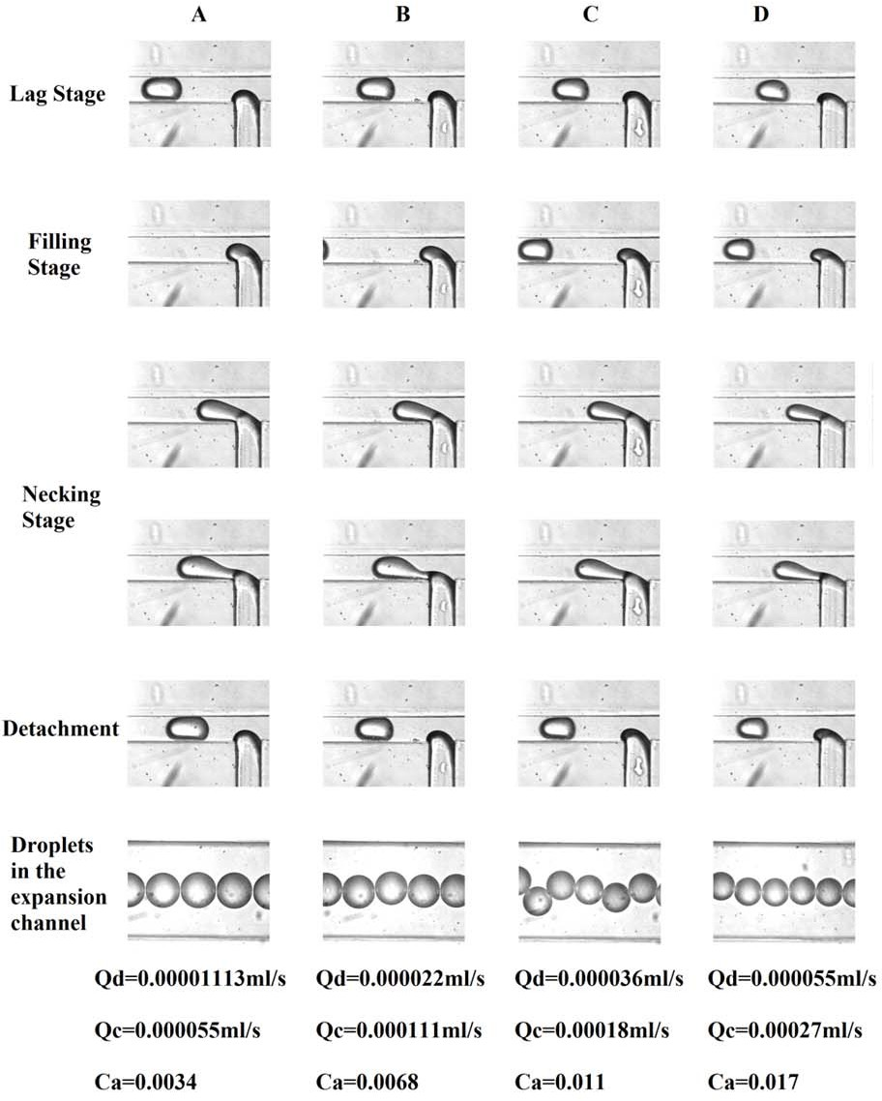

Figure ‑: Chip in squeezing, transition and dripping regimes

**Qd = 0.000055 ml/s  
Qc = 0.00027 ml/s  
Ca = 0.017**

**Qd = 0.000036 ml/s  
Qc = 0.00018 ml/s  
Ca = 0.011**

**Qd = 0.000022 ml/s  
Qc = 0.000111 ml/s  
Ca = 0.0068**

**Qd = 0.0000113 ml/s  
Qc = 0.000055 ml/s  
Ca = 0.034**

### Influence of flow rate ratio Q

The flow rate ratio offers a significant opportunity to adjust the droplet volume for any given capillary number. The complete results of this adjustment are detailed in the Figure 5-6. The capillary number itself is calculated based on the velocity of the oil, which is determined by the amount of oil flowing through the cross-sectional area of the chip's dispersed channel. This relationship between flow rate ratio and capillary number allows for precise control over droplet size in the microfluidic system.

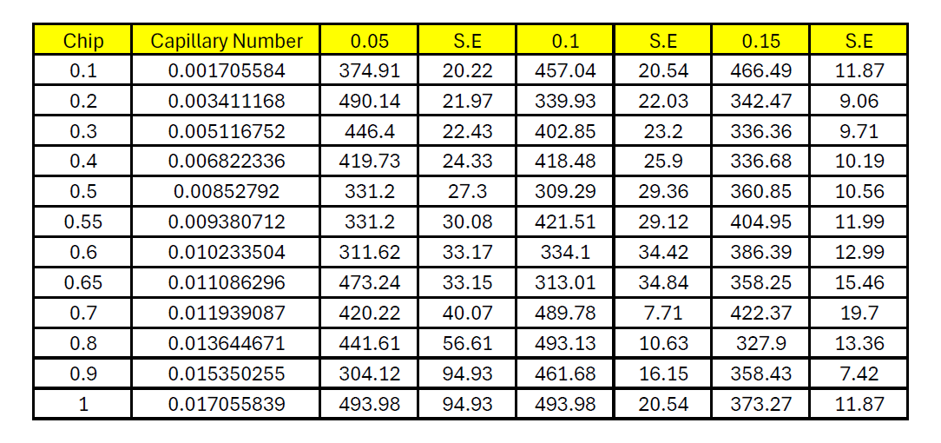

Figure ‑ : The Excel sheet of the measured droplet diameters (µm) and standard error results of Chip 1 for Q= 0.05, 0.1, 0.15

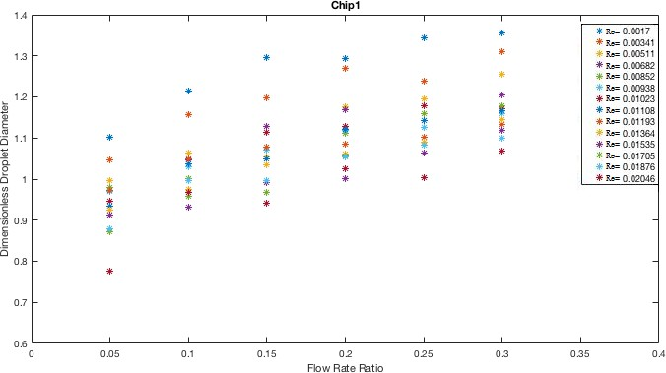

Figure ‑ : The impact of the flow rate ratio on the droplet diameter at the capillary number in a range from 0.0017 to 0.0204 for Chip.

To adjust the flow rate ratio, we need to modify the aqueous flow rate. When the flow rate ratio is low, the droplets are typically generated right at the corner of the T-junction chip. However, as the flow rate ratio increases, indicating that more water is being introduced into the system, the droplet formation shifts downstream, and the breakup occurs further along the channel. In Figure 5-7, it is evident that the droplet size is largest at the smallest capillary number. Unlike the capillary number, the flow rate ratio exerts a strong and continuous influence on the droplet diameter, making it a critical factor in controlling droplet size.

### The Scaling Law

Tan et al. [36] proposed the power-law, following equation, initially for the cross-junction device. It is also suitable for T-junction devices where k, α and β are fitting parameters.

$$\frac{l}{w_{c}}=k{\left(\frac{Q_{C}}{Q_{d}}\right)}^{α}Ca^{β}$$

We employed above Equation (5-1), as proposed by Tan et al. [51], to calculate the dimensionless value of the droplet diameter, which is expressed as a function of both the capillary number and the flow rate ratio. The power fitting results from our experiments are shown in Figures 5-4 and 5-7. To further explore the relationships between these parameters, we rewrote Equation (5-1) as Equation (5-2). This reformulation helps to highlight the correlations between the different factors involved. The superscript β in the equation is a negative value, indicating that the interfacial surface tension plays a significant role in influencing the droplet diameter, as does the flow rate ratio of the dispersed phase. The velocity of the continuous flow, denoted as uc, is calculated using the expression (Qc/wch). From Equation (5-2), it is evident that the droplet diameter decreases as both the continuous phase flow rate ratio and the capillary number increase.

$$d=kQ^{α}{Ca}^{β}$$ We now describe the power law fitting for the microfluidic chip:

$$d=0.5611×Q^{0.08812}×{Ca}^{-0.1749}$$

The coefficients for Chip were calculated using MATLAB, with 95% confidence bounds. The results are as follows:

• k = 0.5611 with confidence bounds of (0.4329, 0.6892)

• α = 0.08812 with confidence bounds of (-0.003748, 0.18)

• β = −0.1749 with confidence bounds of (-0.2575, -0.09229)

These values provide a reliable estimation of the relationship between the droplet diameter, flow rate, and capillary number for the chip.

## Conclusions

The flow patterns were analyzed by examining the effects of the flow rate ratio, capillary number, and channel geometry. It was observed that as the flow rate ratio Qn increased, the number of microdroplets also increased, causing them to become more densely packed. Similarly, an increase in the capillary number resulted in a tighter flow pattern with smaller droplet sizes. In chips with deeper structures, even when the droplets were of similar size, the flow pattern shifted from a double helix to a triple helix in three dimensions, providing more space for the droplets.

Throughout our experiments, we consistently observed the squeezing regime at low capillary numbers and the dripping regime at high capillary numbers. Additionally, we identified a transition area where the flow regime was neither fully squeezing nor dripping. As the capillary number increased, the droplet diameter decreased, but within a specific range of parameters, we noted a critical change. Around the capillary number (0.01 < Ca < 0.015), the trend of shrinking droplet size began to slow down, likely due to a regime change. An increase in the flow rate ratio tended to increase the droplet size. Our microfluidic chip provided a clearer view of the transition from the squeezing to the dripping regimes. The power laws described in Equations (5.2) and (5.3) were derived from the trends observed in Figures 5-4 and 5-7.

# References

[1] R. M. van Dam, “Solvent-resistant elastomeric microfluidic devices and applications,” California Institute of Technology, 2006.

[2] G. M. Whitesides, “The origins and the future of microfluidics,” Nature, vol. 442, no. 7101, pp. 368–373, 2006.

[3] A. Manz, N. Graber and H.M.Widmer, “Miniaturized Total Chemical Analysis Systems: a Novel Concept for Chemical Sensing,” Sensors Actuators, BI, pp. 244–248, 1990.

[4] K. Chen and Z. Hugh Fan, *Introduction to Microfluidics*: Wiley Online Library, 2005.

[5] M.T. Sullivan and H.A. Stone, “The role of feedback in microfluidic flow-focusing devices,” *Philosophical Transactions of the Royal Society of London A: Mathematical, Physical and Engineering Sciences,* vol. 336, pp. 2131-2143, 2008.

[6] X.C i Solvas, “Droplet microfluidics: recent developments and future applications,” *Chemical Communications*, vol. 47 , pp. 1936-1942, 2011.

[7] T. Thorsen, R. W. Roberts, F. H. Arnold, and S. R. Quake, “Dynamic pattern formation

in a vesicle-generating microfluidic device,” Phys. Rev. Lett., vol. 86, no. 18, pp. 4163–

4166, 2001.

[8] S. L. Anna, N. Bontoux, and H. A. Stone, “Formation of dispersions using ‘flow

focusing’ in microchannels,” Appl. Phys. Lett., vol. 82, no. 3, pp. 364–366, 2003.

[9] P. B. Umbanhowar, V. Prasad, and D. A. Weitz, “Monodisperse emulsion generation

via drop break off in a coflowing stream,” Langmuir, vol. 16, no. 2, pp. 347–351, 2000.

[10] S. H. Jin, H. H. Jeong, B. Lee, S. S. Lee, and C. S. Lee, “A programmable microfluidic

static droplet array for droplet generation, transportation, fusion, storage, and retrieval,” Lab Chip, vol. 15, no. 18, pp. 3677–3686, 2015.

[11] D. J. Collins, T. Alan, K. Helmerson, and A. Neild, “Surface acoustic waves for on demand production of picoliter droplets and particle encapsulation.,” Lab Chip, vol. 13, no. 16, pp. 3225–3231, 2013.

[12] R. Ahmed and T. B. Jones, “Dispensing picoliter droplets on substrates using dielectrophoresis,” J. Electrostat., vol. 64, no. 7–9, pp. 543–549, 2006.

[13] S. K. Cho, H. Moon, and C. J. Kim, “Creating, transporting, cutting, and merging liquid

droplets by electrowetting-based actuation for digital microfluidic circuits,” J.

Microelectromechanical Syst., vol. 12, no. 1, pp. 70–80, 2003.

[14] S. M. S. Murshed, S. H. Tan, N. T. Nguyen, T. N. Wong, and L. Yobas, “Microdroplet

formation of water and nanofluids in heat-induced microfluidic T-junction,” Microfluid.

Nanofluidics, vol. 6, no. 2, pp. 253–259, 2009.

[15] Y. F. Yap, S. H. Tan, N. T. Nguyen, S. M. S. Murshed, T. N. Wong, and L. Yobas,

“Thermally mediated control of liquid microdroplets at a bifurcation,” J. Phys. D. Appl.

Phys., vol. 42, no. 6, 2009.

[16] A. R. Abate, M. B. Romanowsky, J. J. Agresti, and D. A. Weitz, “Valve-based flow

focusing for drop formation,” Appl. Phys. Lett., vol. 94, no. 2, pp. 92–95, 2009.

[17] L. Schmid and T. Franke, “SAW-controlled drop size for flow focusing,” Lab Chip, vol.

13, no. 9, p. 1691, 2013.

[18] L. Schmid and T. Franke, “Acoustic modulation of droplet size in a T-junction,” Appl.

Phys. Lett., vol. 104, no. 13, p. 133501, 2014.

[19] P. Garstecki, M. J. Fuerstman, H. A. Stone, and G. M. Whitesides, “Formation of

droplets and bubbles in a microfluidic T-junction - Scaling and mechanism of breakup,” Lab Chip, vol. 6, no. 3, pp. 437–446, 2006.

[20] M. De Menech, P. Garstecki, F. Jousse, and H.A.Stone, “Transition from squeezing to

dripping in a microfluidic T-shaped junction,” J. Fluid Mech., vol. 595, pp. 141–161,

2008.

[21] P. Garstecki, M. Fuerstman, and G. M. H A Stone Whitesides, “Formation of droplets

and bubbles in a microfluidic T-junction-scaling and mechanism of break-up.,” Lab

Chip, vol. 6, no. 3, pp. 437–446, 2006.

[22] Adapted from J. C. McDonald and G. M. Whitesides, “Poly(dimethylsiloxane) as a mate rial for fabricating microfluidic devices,” Acc. Chem. Res., 35, (2002), 491–499.)

[23] Nam-Trung Nguyen and Steven T. Wereley, “Fundamental and Applications of Microfluidics” Second Edition Table 10.2 *Page 359.*

[24] X. Niu, F. Gielen, J. B. Edel, and A. J. DeMello, “A microdroplet dilutor for high-throughput screening,” Nat. Chem., vol. 3, no. 6, pp. 437–442, 2011.

[25] D. J. Collins, T. Alan, K. Helmerson, and A. Neild, “Surface acoustic waves for on-demand production of picoliter droplets and particle encapsulation.,” Lab Chip, vol. 13, no. 16, pp. 3225–3231, 2013.

[26] M. De Menech, P. Garstecki, F. Jousse, and H.A.Stone, “Transition from squeezing to dripping in a microfluidic T-shaped junction,” J. Fluid Mech., vol. 595, pp. 141–161, 2008.

[27] P. Garstecki, M. J. Fuerstman, H. A. Stone, and G. M. Whitesides, “Formation of droplets and bubbles in a microfluidic T-junction - Scaling and mechanism of break-up,” Lab Chip, vol. 6, no. 3, pp. 437–446, 2006.

[28] T. Thorsen, R. W. Roberts, F. H. Arnold, and S. R. Quake, “Dynamic pattern formation in a vesicle-generating microfluidic device,” Phys. Rev. Lett., vol. 86, no. 18, pp. 4163–4166, 2001.

[29] D. R. Link, S. L. Anna, D. A. Weitz, and H. A. Stone, “Geometrically Mediated Breakup of Drops in Microfluidic Devices,” Phys. Rev. Lett., vol. 92, no. 5, p. 054503, 2004.

[30] L. Ménétrier-Deremble and P. Tabeling, “Droplet breakup in microfluidic junctions of arbitrary angles,” Phys. Rev. E, vol. 74, no. 3, p. 035303(R), 2006.

[31] M. C. Jullien, M. J. Tsang Mui Ching, C. Cohen, L. Menetrier, and P. Tabeling, “Droplet breakup in microfluidic T-junctions at small capillary numbers,” Phys. Fluids, vol. 21, no. 7, p. 072001, 2009.

[32] S. Bashir, J.M. Rees and W.B. Zimmerman. Investigation of pressure profile evolution during confined microdroplet formation using a two-phase level set method. International Journal of Multiphase Flow, 60(2014): 40-49. Elsevier, 2014.

[33] P.M. Korczyk, M.E. Dolega, S. Jakiela, P. Jankowski, S.Makulska and P. Garstecki. Scaling up the throughput of synthesis and extraction in droplet microfluidic reactors. Journal of Flow Chemistry, 5(2): 110-118. Akadémiai Kiadó, 2015.

[34] P. Garstecki, M.J. Fuerstman, H.A. Stone and G.M. Whitesides. Formation of droplets and bubbles in a microfluidic T-junction–scaling and mechanism of break-up. Lab Chip 6:437–446. Royal Society of Chemistry, 2006.

[35] M. De Menech, P. Garstecki, F. Jousse and H.A. Stone. Transition from squeezing to dripping in a microfluidic T- shaped junction. Journal of Fluid Mechanics 595: 141–161. Cambridge University Press, 2008.

[36] J. Tan, J. Xu, S. Li and G. Luo. Drop dispenser in a cross-junction microfluidic device: scaling and mechanism of break-up. Chemical Engineering Journal, 136(2-3): 306–311. Elsevier, 2008.